COVID-19 chatbot with Google Dialogflow & AMAZONE LEX

1. **Chatbot Fundamentals**
   1. **What is a chatbot?**

**A chatbot is a software application used to conduct an on-line chat conversation via text or text-to-speech, in lieu of providing direct contact with a live human agent.Today, most chatbots are accessed on-line via website popups, or through virtual assistants such as Google Assistant, Amazon Alexa, or messaging apps such as Facebook Messenger or WeChat.**

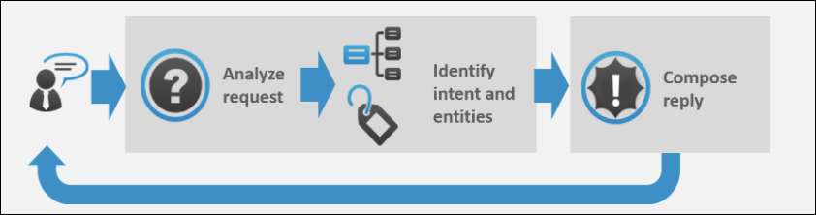

Image Courtesy: <https://expertsystem.com/chatbot/>

* 1. **Uses of chatbots:**

**Here are some of the use case of chatbot:-**

1. **Chatbots Answer Questions And Inquiries**
2. **Book Tickets To Events/Shows With Chatbots**
3. **Use Chatbots To Find Products, Check Inventory and Recommend Items**
4. **Chatbots To Build Remarkable Customer Experience**
5. **Chatbots Can Confirm Orders And Track Shipping**
6. **Chatbots Can Do Quizzes, Promotions, And Contests With Customers**
7. **Chatbots Become Personal Shopping Assistants**
   1. **Advantages of Chatbots**
8. **1- 24 hour availability**
9. **Keeping Up with the Trends: Being Present on Messaging Platforms**
10. **Improved Customer Service**
11. **Increased Customer Engagement**
12. **Cost Savings**
13. **Management of multiple clients**
14. **Gaining a deeper understanding of customers**
15. **Google Dialogflow**
    1. **Introduction:**

**Dialogflow is an end-to-end, build-once deploy-everywhere development suite for creating conversational interfaces for websites, mobile applications, popular messaging platforms, and IoT devices. You can use it to build interfaces (such as chatbots and conversational IVR) that enable natural and rich interactions between your users and your business**

**Dialogflow can analyze multiple types of input from your customers, including text or audio inputs (like from a phone or voice recording). It can also respond to your customers in a couple of ways, either through text or with synthetic speech.**

* 1. **Signup For Dialogflow:**

**You need to have a google account to signup for Dialogflow.**

1. **Go to** <https://dialogflow.com/> **and click on ‘Sign Up for Free’ button.**

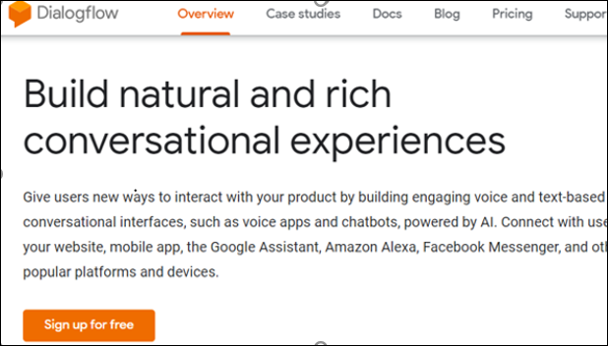

1. **Click ‘sign-in with Google’.**

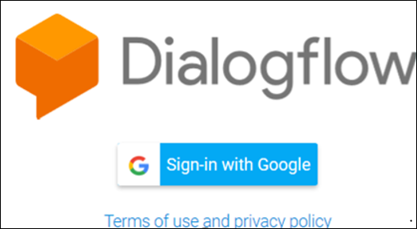

1. **Select your google account and once you are redirected, click on ‘Go To Console’ on the upper right corner of the screen.**
   1. **Dialogflow Console:**

**Dialogflow provides a web user interface called the *Dialogflow Console*** ([open console](https://dialogflow.cloud.google.com/)). **The console is used to create, build, manage, fine-tune, and test your agents. With it, you can**:

* **Create**[**agents**](https://cloud.google.com/dialogflow/docs/agents-overview)**that define the conversational experienceCreate Intents**
* **Create**[**intents**](https://cloud.google.com/dialogflow/docs/intents-overview)**that map user input to responses**
* **Create** [**entities**](https://cloud.google.com/dialogflow/docs/entities-overview) **to extract useful data from user input**
* **Control conversation paths with** [**contexts**](https://cloud.google.com/dialogflow/docs/contexts-overview)
* [**Integrate**](https://cloud.google.com/dialogflow/docs/integrations) **with other conversational platforms**
* **Implement** **[fulfillment](https://cloud.google.com/dialogflow/docs/fulfillment-overview)** **to connect your service when using integrations**
* [**Analyze**](https://cloud.google.com/dialogflow/docs/analytics) **agent performance**

1. **Building a chatbot using google Dialogflow**
   1. **The problem statement:**

**Build a covid-19 chatbot, which will be able to tell a number of cases available in any of the locality by there Pincode or district or state , and it will give all the instruction and preventive measures.**

* 1. **Agent:**

**A Dialogflow *agent* is a virtual agent that handles conversations with your end-users. It is a natural language understanding module that understands the nuances of human language. A Dialogflow agent is similar to a human call center agent. You train them both to handle expected conversation scenarios, and your training does not need to be overly explicit.**

* + 1. **Creating an Agent:**
  1. **Click on *Create Agent* from the left menu.**

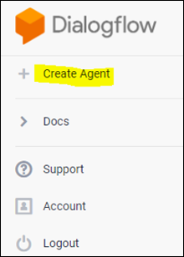

* 1. **Provide the name of the agent and click on the *SAVE* button to create the Agent.**

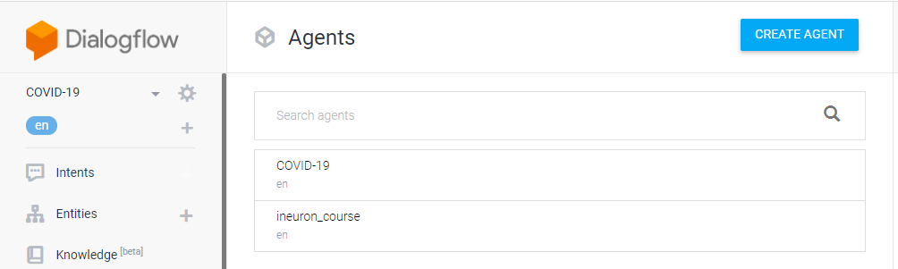

* 1. **After saving, the agent is shown in the left hand side of your console. You can click the gear icon to edit the agent settings.**

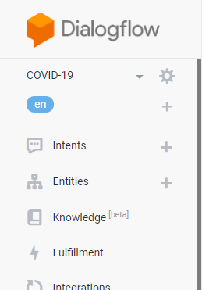

* 1. **Intent:**

**An *intent* categorizes an end-user's intention for one conversation turn. For each agent, you define many intents, where your combined intents can handle a complete conversation. When an end-user writes or says something, referred to as an *end-user expression*, Dialogflow matches the end-user expression to the best intent in your agent. Matching an intent is also known as *intent classification*.**

**The following diagram shows the basic flow for intent matching and responding to the end-user:**

**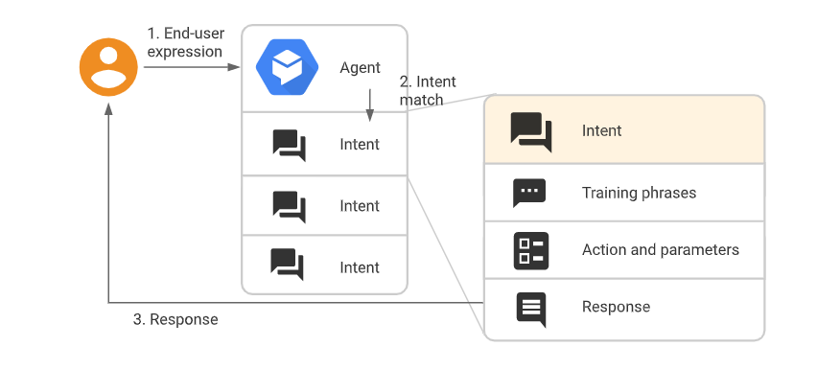**

* + 1. **Creating an Intent:**
    2. **Click the + add button next to**Intents**in the left sidebar menu. Enter a name for your intent. Your intent name should represent the end-user expressions it recognizes and click** Save**.**

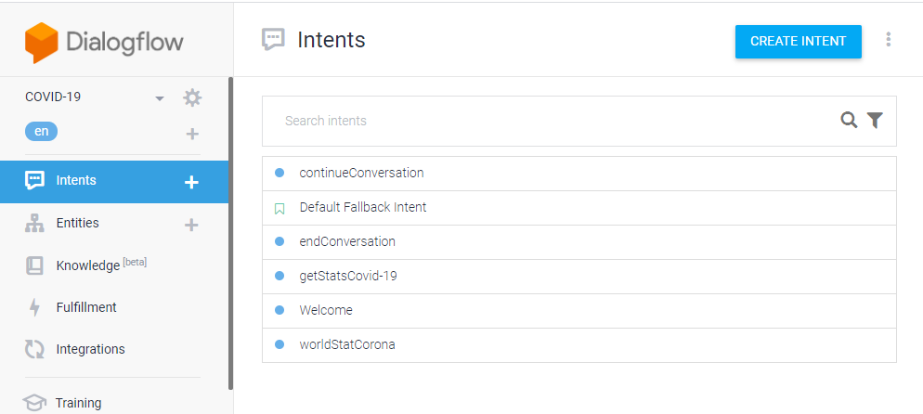

* + - 1. **Training Phrases:**

***Training phrases* are example phrases for what end-users might type or say, referred to as *end-user expressions*. For each intent, you create many training phrases. When an end-user expression resembles one of these phrases, Dialogflow matches the intent.**

**For example, the training phrase "I want pizza" trains your agent to recognize end-user expressions that are similar to that phrase, like "Get a pizza" or "Order pizza".**

**Adding the training Phrases:**

1. **Click the text field that shows "Add user expression".**
2. **Type your training phrases and press the Enter key after each.**

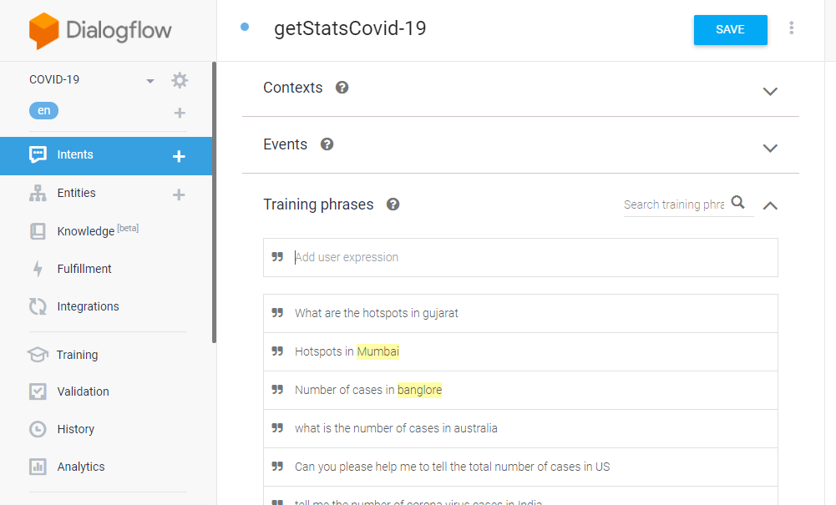

* + - 1. **Extracting the Entities:**

**When an intent is matched at runtime, Dialogflow provides the extracted values from the end-user expression as *parameters*. Each parameter has a type, called the**[**entity type**](https://cloud.google.com/dialogflow/docs/entities-overview)**, which dictates exactly how the data is extracted. Unlike raw end-user input, parameters are structured data that can easily be used to perform some logic or generate responses.**

**Each intent**[**parameter**](https://cloud.google.com/dialogflow/docs/intents-actions-parameters#params)**has a type, called the *entity type*, which dictates exactly how data from an end-user expression is extracted.**

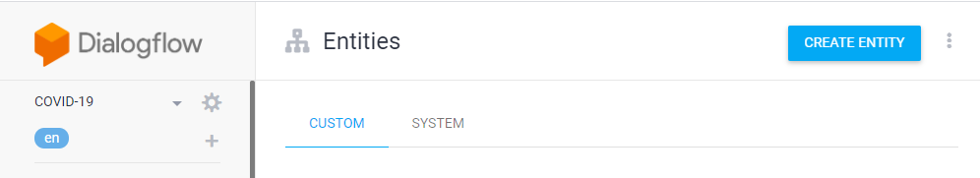

**Dialogflow provides predefined**[**system entities**](https://cloud.google.com/dialogflow/docs/entities-system)**that can match**

**many common types of data. For example, there are system entities for matching dates, times, colors, email addresses, and so on. You can also create your own**[**custom entities**](https://cloud.google.com/dialogflow/docs/entities-custom)**for matching custom data.**

* + - 1. **Specifying custom Responses:**

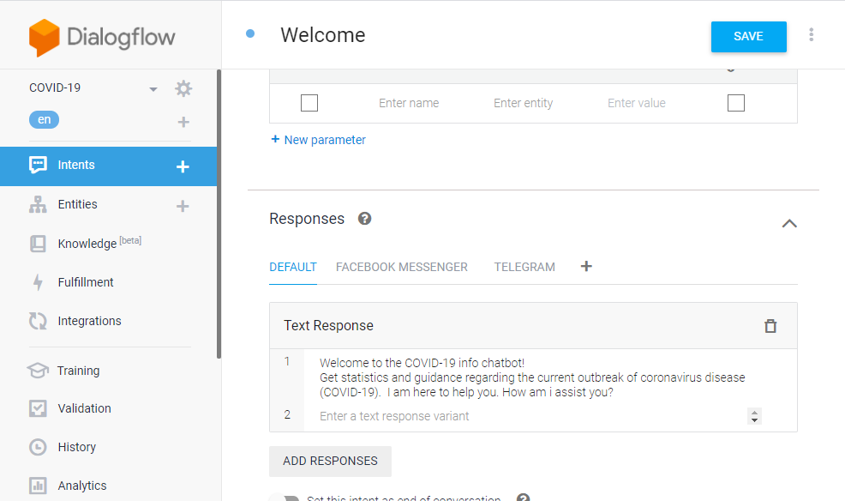**Intents have a built-in response handler that can return responses after the intent is matched. This feature only supports static responses, though you can use**[**parameter references**](https://cloud.google.com/dialogflow/docs/intents-actions-parameters#values)**in these responses to make them somewhat dynamic. This is helpful for recapping information provided by the end-user. For example, your intent response could look like: "Okay, I booked a room for you on $date".**



* 1. **Fulfillment:**

**By default, your agent responds to a matched intent with a static response. If you're using one of the**[**integration**](https://cloud.google.com/dialogflow/docs/integrations)**options, you can provide a more dynamic response by using *fulfillment*. When you enable fulfillment for an intent, Dialogflow responds to that intent by calling a service that you define. For example, if an end-user wants to schedule a haircut on Friday, your service can check your database and respond to the end-user with availability information for Friday.**

**Each**[**intent**](https://cloud.google.com/dialogflow/docs/intents-overview)**has a setting to enable fulfillment. If an intent requires some action by your system or a dynamic response, you should enable fulfillment for the intent. If an intent without fulfillment enabled is matched, Dialogflow uses the static response you defined for the intent.**

**When an intent with fulfillment enabled is matched, Dialogflow sends a request to your *webhook* service with information about the matched intent. Your system can perform any required actions and respond to Dialogflow with information for how to proceed. The following diagram shows the processing flow for fulfillment.**

**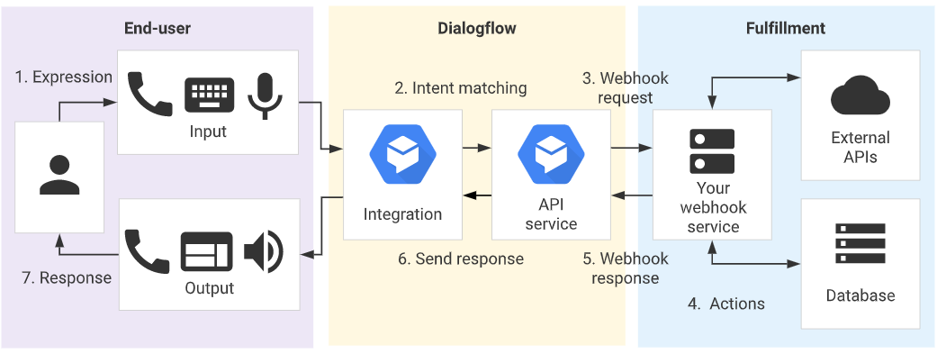**

1. **The end-user types or speaks an expression.**
2. **Dialogflow matches the end-user expression to an intent and extracts parameters.**
3. **Dialogflow sends a [webhook request](https://cloud.google.com/dialogflow/docs/fulfillment-webhook" \l "webhook_request) message to your webhook service. This message contains information about the matched intent, the action, the parameters, and the response defined for the intent.**
4. **Your service performs actions as needed, like database queries or external API calls.**
5. **Your service sends a**[**webhook response**](https://cloud.google.com/dialogflow/docs/fulfillment-webhook#webhook_response)**message to Dialogflow. This message contains the response that should be sent to the end-user.**
6. **Dialogflow sends the response to the end-user.**
7. **The end-user sees or hears the response.**
   * 1. **Functionalities achived in fulfilment:**
   1. **Sending an email to the customer with the syllabus and all the course details based on the course selected.**
   2. **Sending an email to the Support team to further contact the customer for further clarification.**
      1. **Webhook for fulfilment:**
      2. **Select**Fulfillment**in the left sidebar menu.**
      3. **Toggle the**Webhook**field to**Enabled**.**
      4. **Provide the details for your webhook service in the form. If your webhook doesn't require authentication, leave the authentication fields blank.**
      5. **Click**Save**at the bottom of the page.**

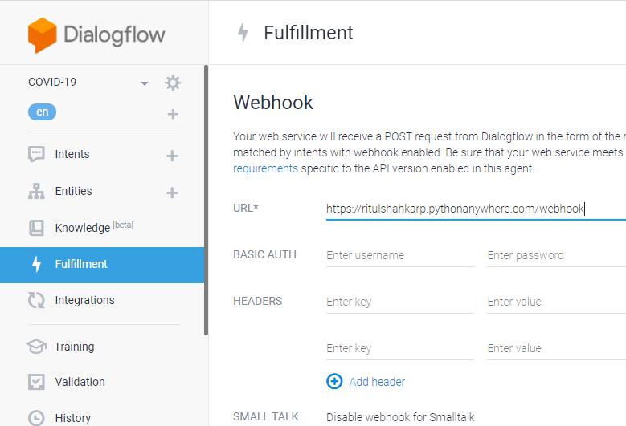

* 1. **Test the Agent:**

**You can now test the agent from the ‘test it now’ section.**

**You can see entire working chatbot conversation in below snapshots:**

***Welcome conversation***

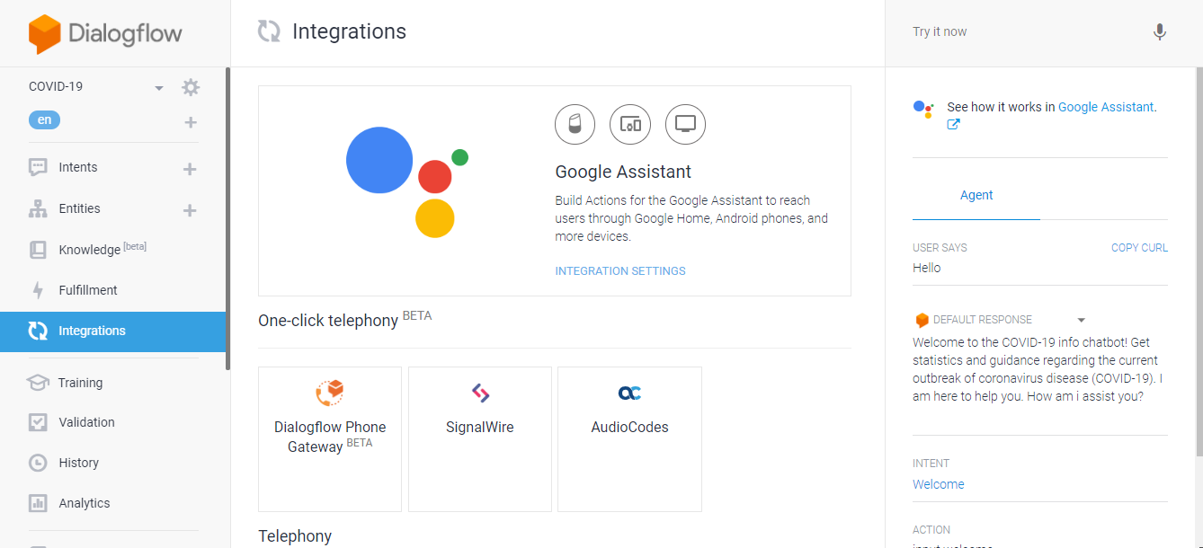

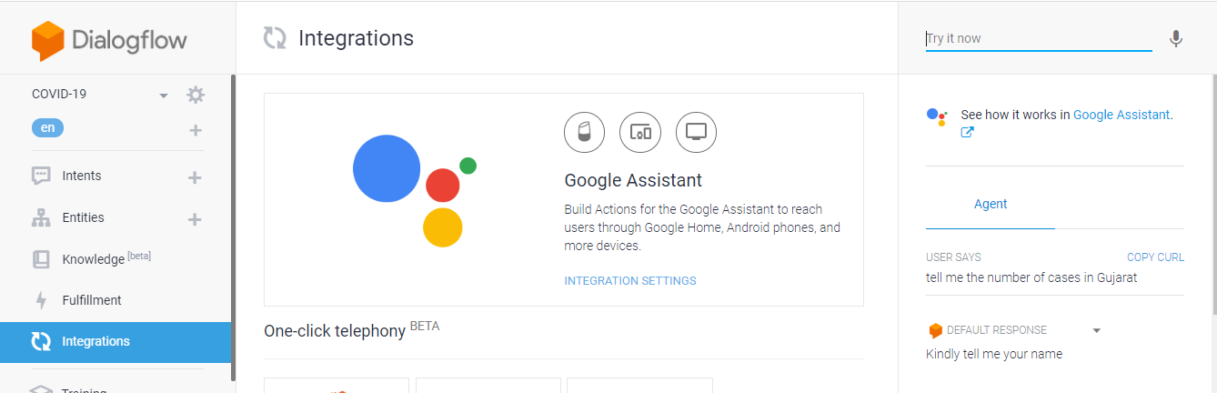***Lets check coronavirus cases in India by asking pin-code:-***

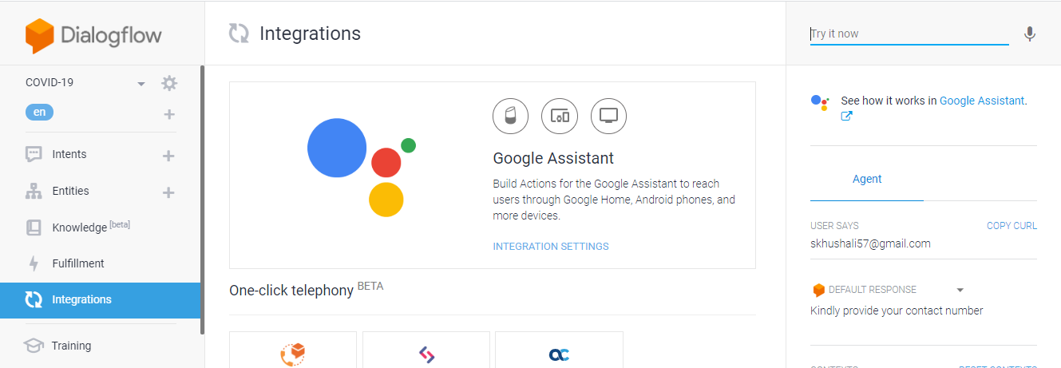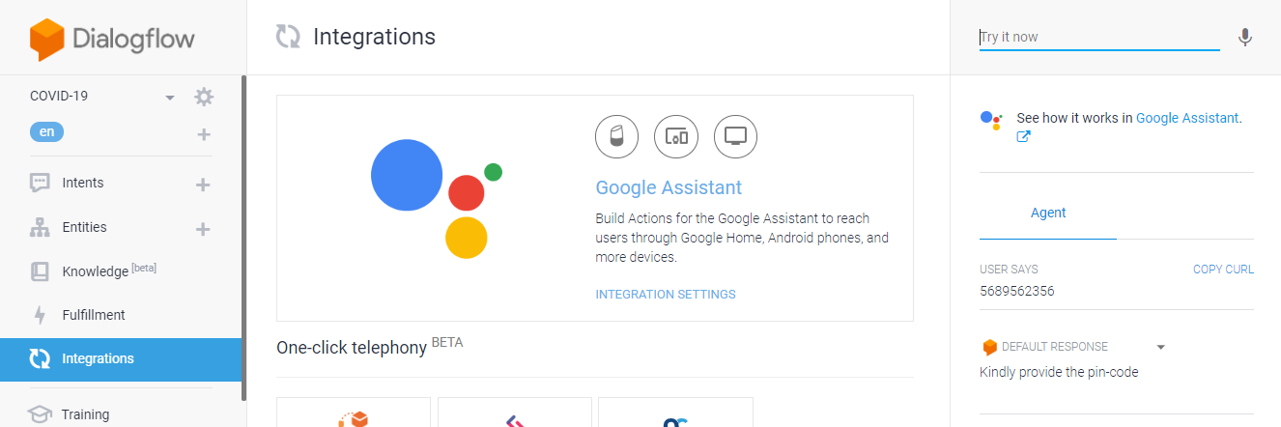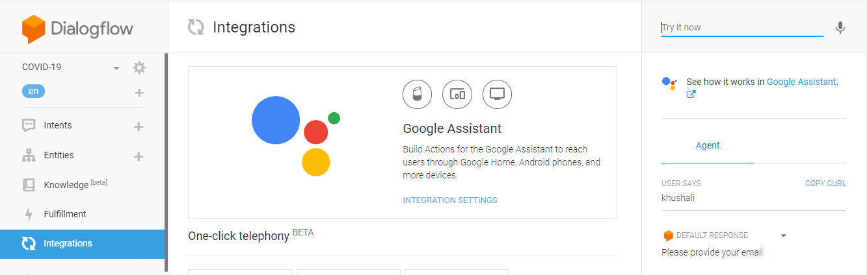

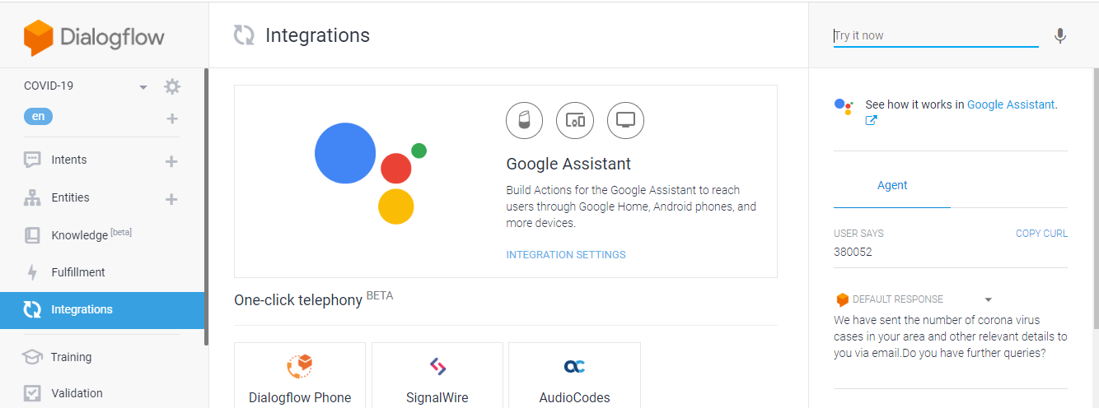

**Lets check the email:-**

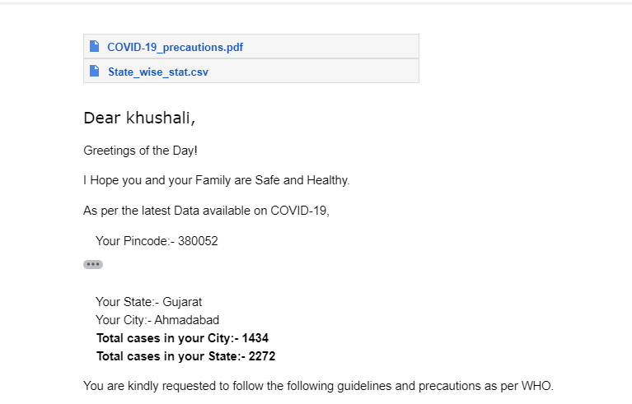

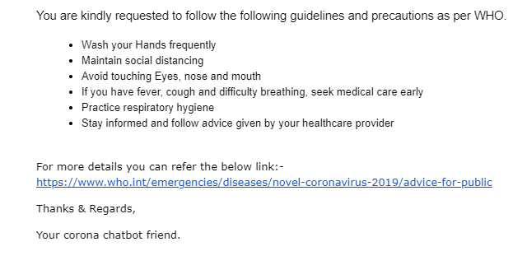

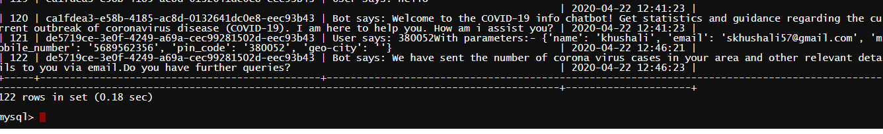**Lets check the database entry:-**

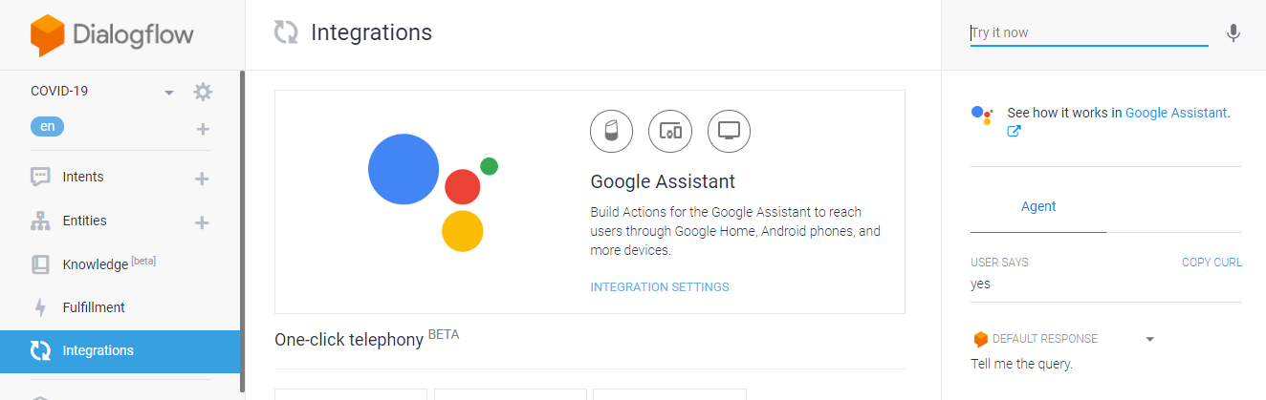**Now, lets continue the conversation:-**

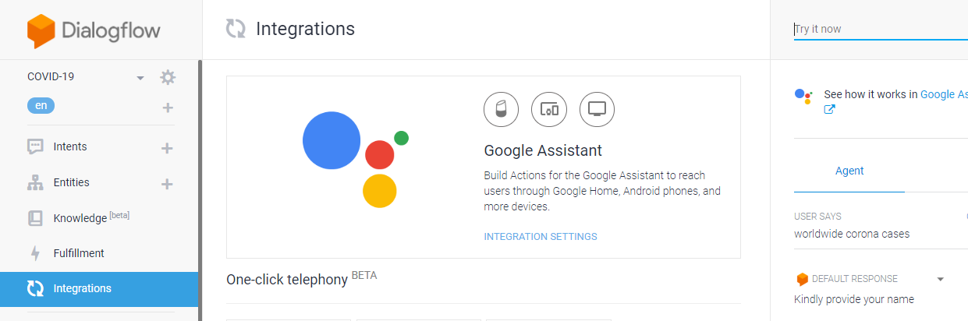**Now, lets check for world-wide data**

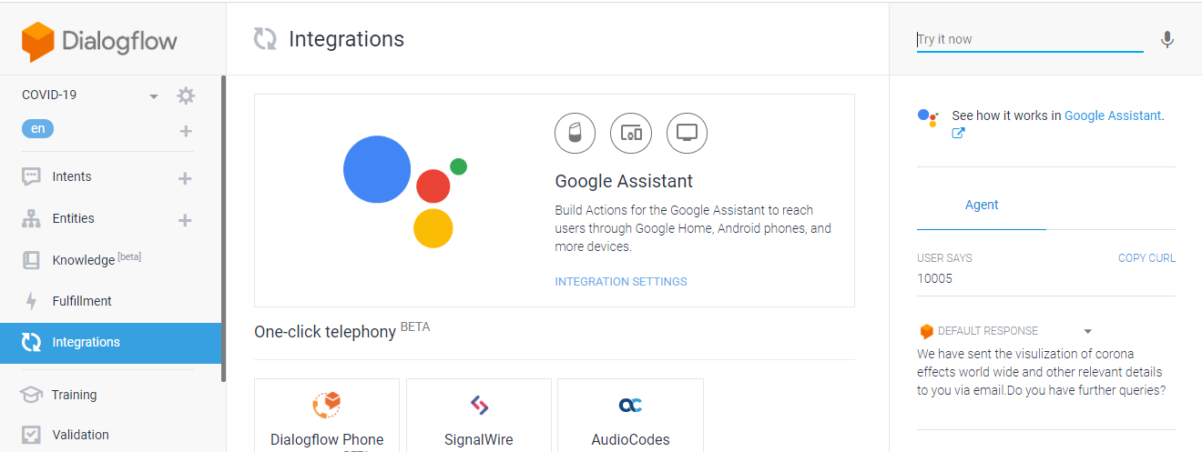

**Check the email:-**

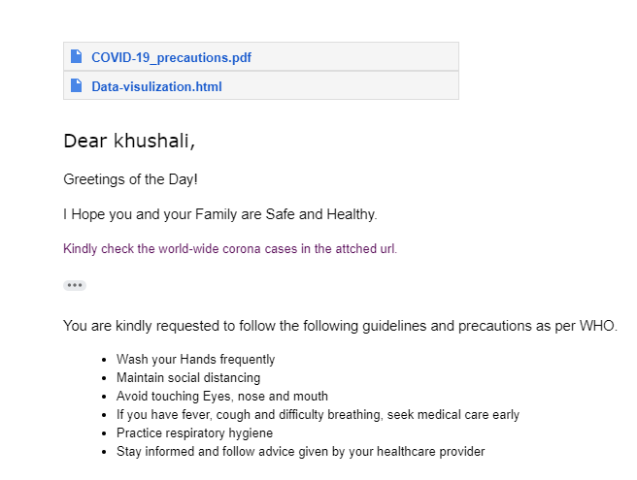

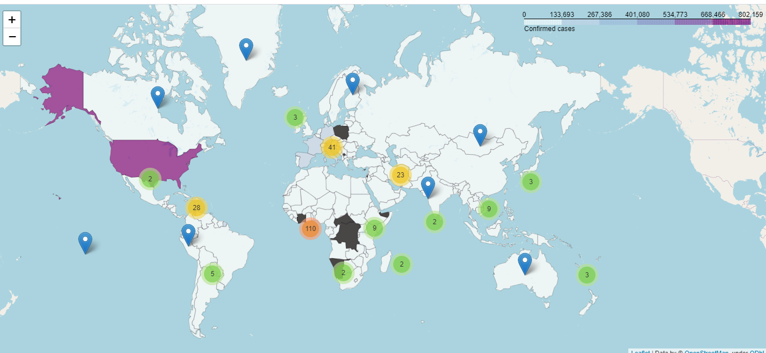**Now lets check the url**

**So, here its showing data globally.**

**Now , click on any green-yellow color circle, itwill expand the map locations. Lets check.Expanding red portion in the above map.**

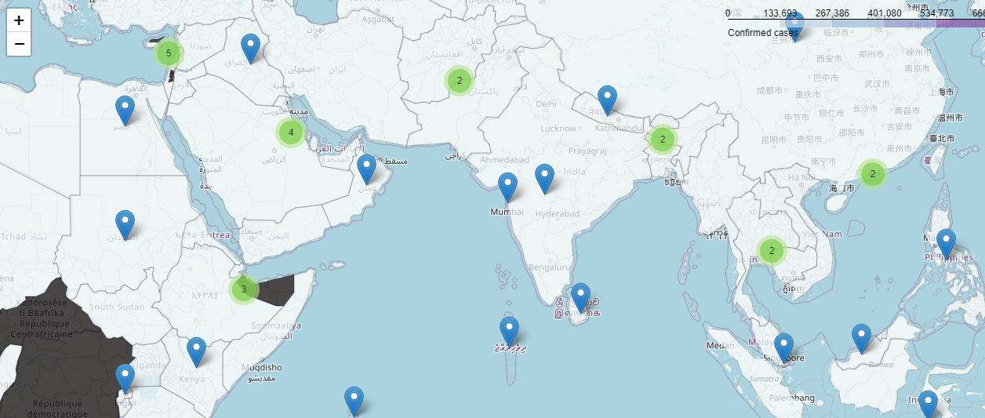

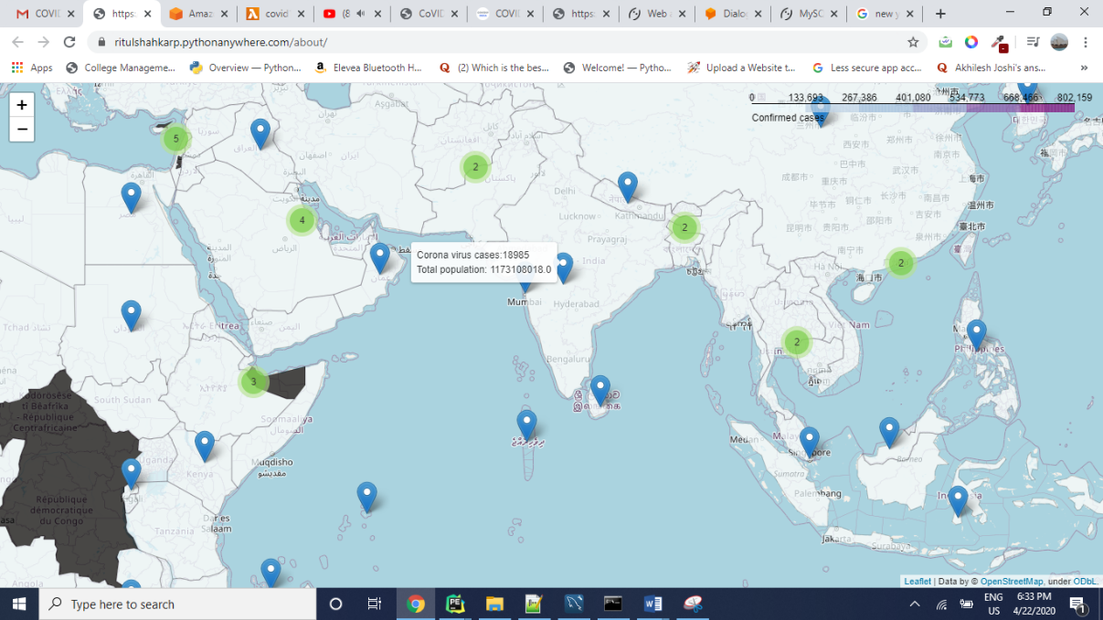**Now, lets hover over the location symbol:-**

**Now, click on this location symbol, It will show No. of confirmed cases, recoverd cases and death.**

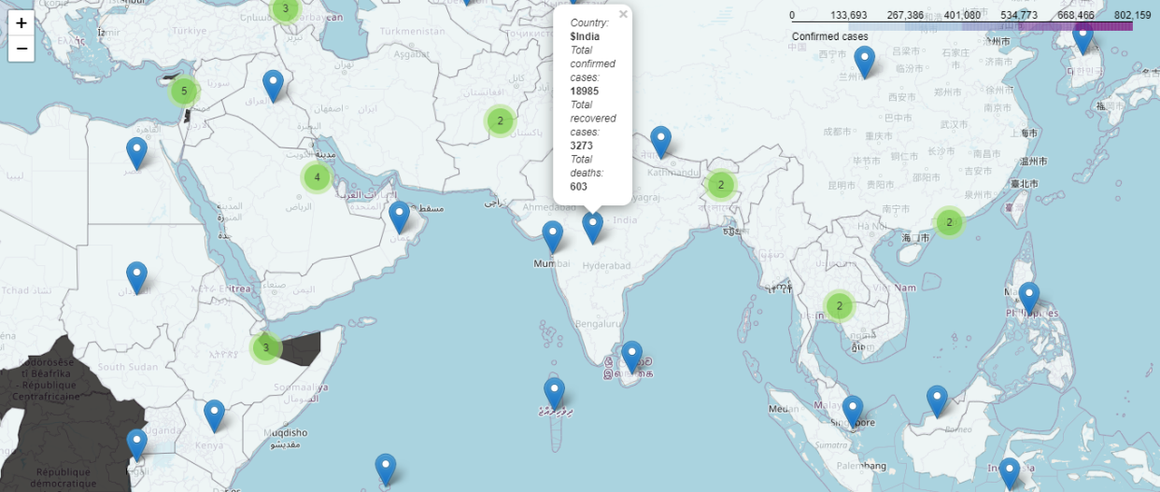

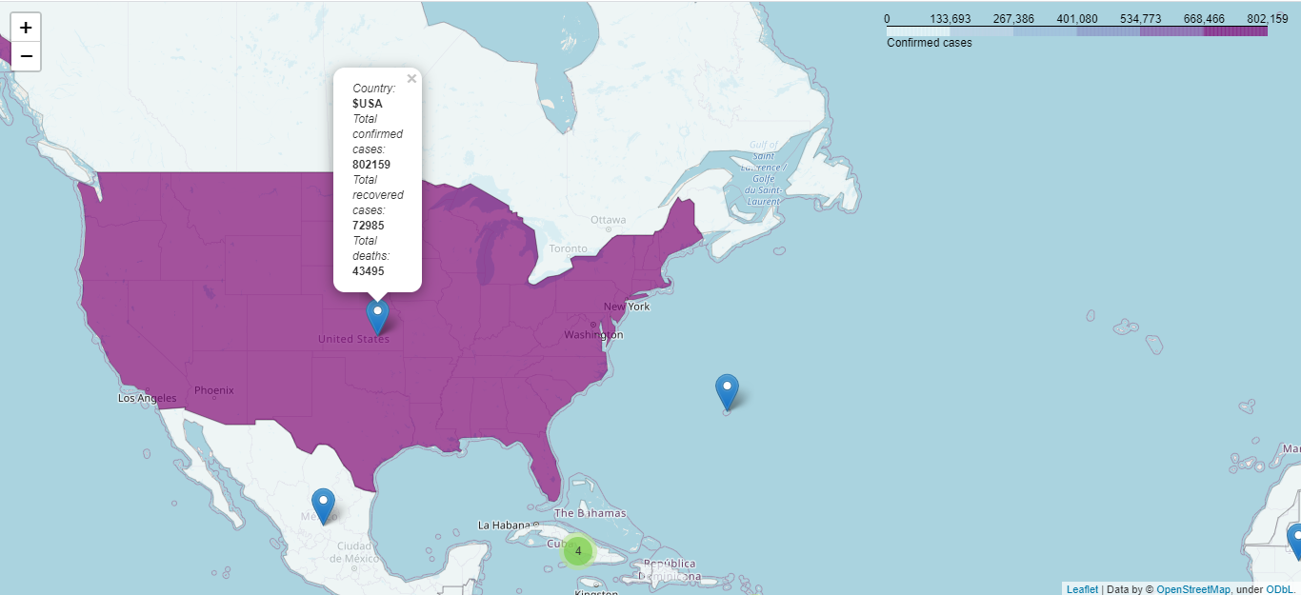

**Now, lets check for the condition where I am giving pincode outside of india.**

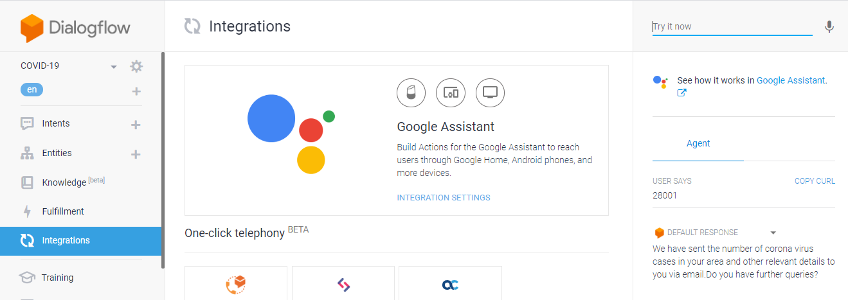

**Lets check the email**

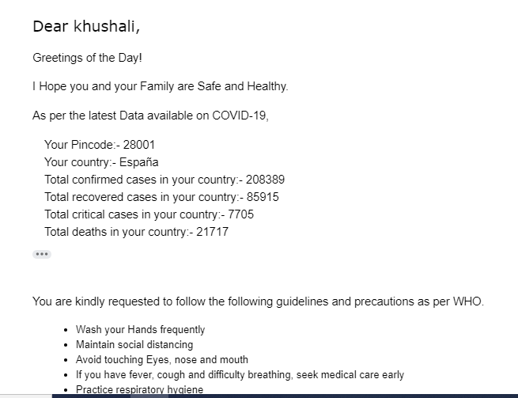

**Lets end the conversation:-**

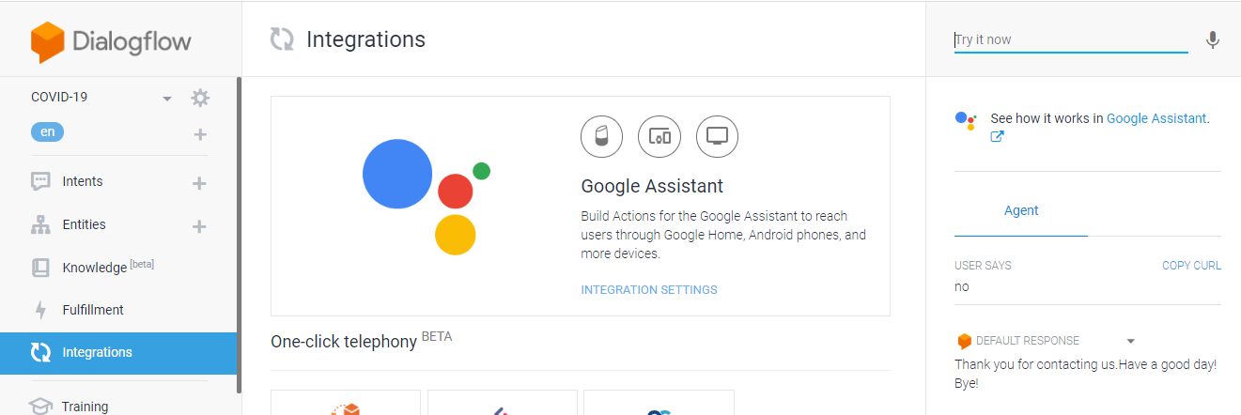

**Lets check DB Entries:-**

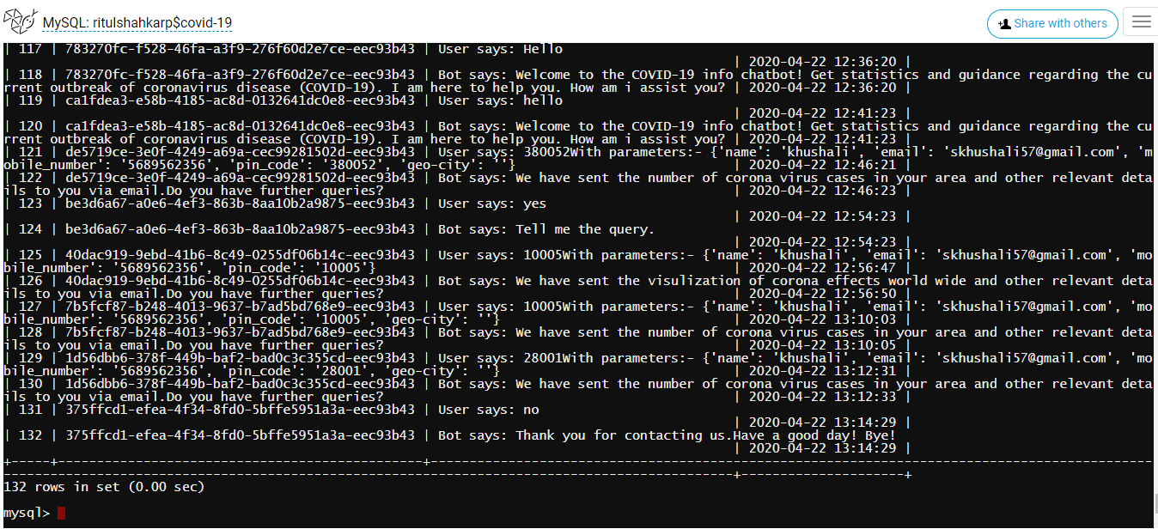

* 1. **Integration:**

**Dialogflow integrates with many popular conversation platforms like Google Assistant, Slack, and Facebook Messenger. If you want to build an agent for one of these platforms, you should use one of the many *integrations* options. Direct end-user interactions are handled for you, so you can focus on building your agent.**

**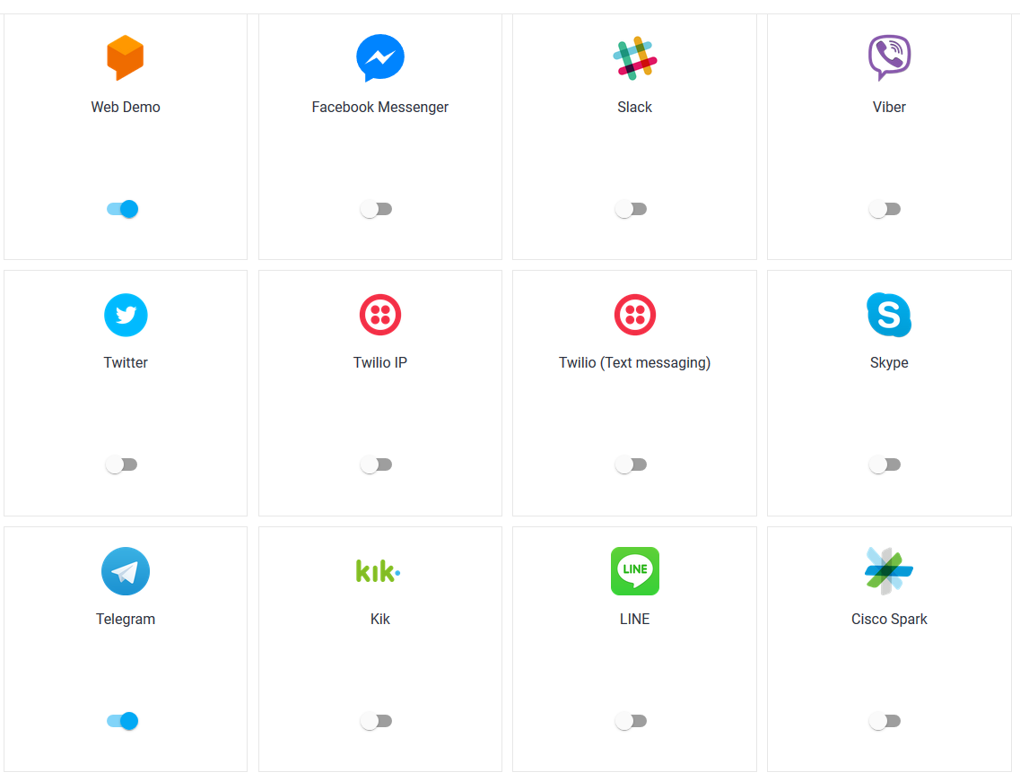**

* + 1. **Integration with Telegram:**

**Dialogflow Telegram Integration allows you to easily create Telegram bots with natural language understanding based on the Dialogflow technology.**

**In order to set up the Telegram integration for your agent, you'll need the following:**

1. [Telegram account](https://web.telegram.org/#/login).

### **3.7.1.2 Creating a Bot in Telegram**

1. **Login to Telegram and go to** <https://telegram.me/botfather>
2. **Click the**Start**button in the web interface or type /start**
3. **Click on or type**/newbot**and enter a name**
4. **Enter a username for the bot, ending in "bot" (e.g. garthsweatherbot)**
5. **Copy the generated access token**

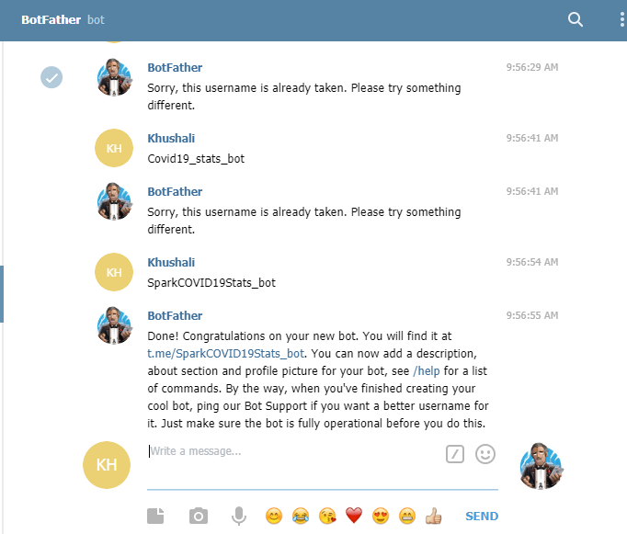

## **3.7.1.3 Setting Up Dialogflow**

1. **In Dialogflow, go to Integrations in the left hand menu**
2. **Click on the Telegram tile**
3. **Paste the Access Token into the related field**
4. **Click the Start button**

**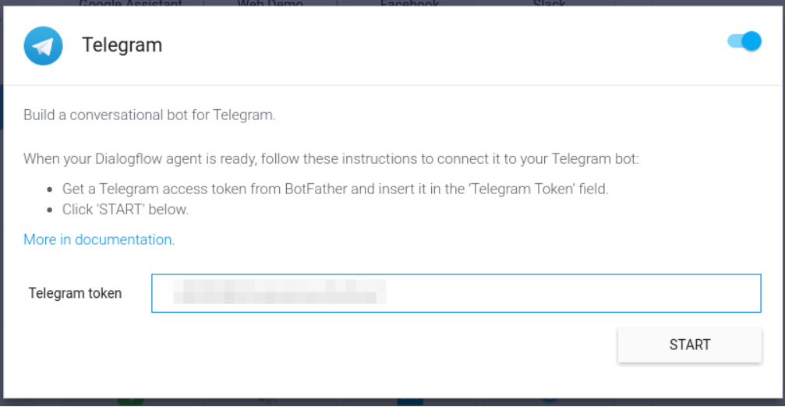**

**Now you can search your bot in telegram and you can chat with it.**

**Telegram id:- @SparkCOVID19Stats\_bot**

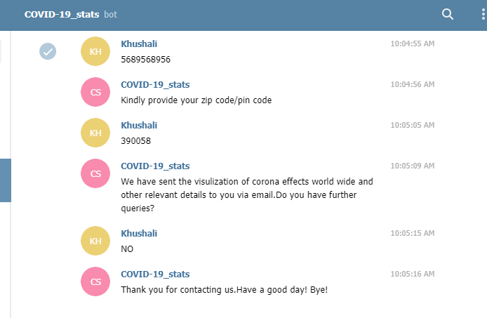

* + 1. **Integration with Facebook:**

**Follow below mentioned steps for Facebook integration:-**

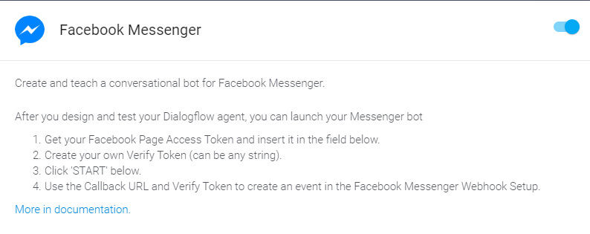

Facebook messanger working chat-bot:-

Facebook-page:- **COVID-19\_stats**

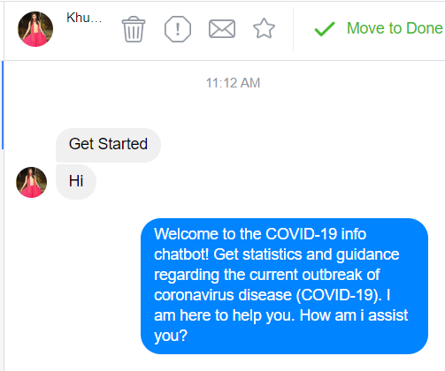

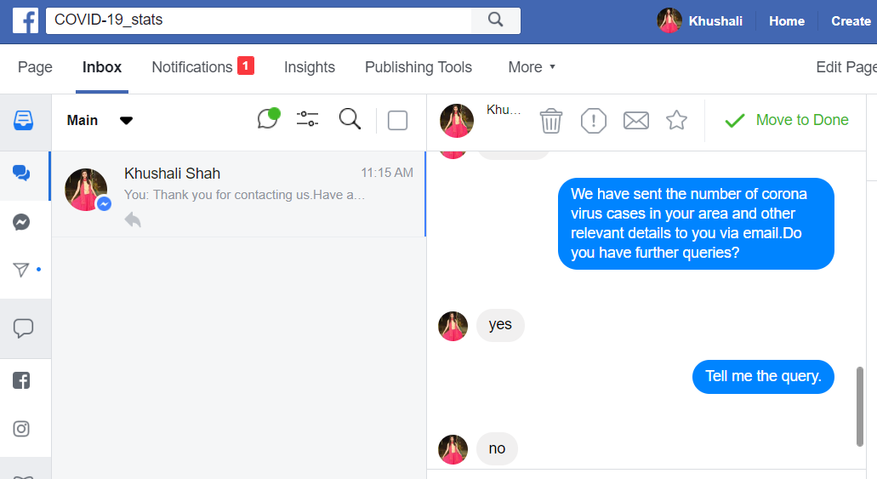

# **Amazon Lex**

## **Introduction**

Amazon Lex is an AWS service for building conversational interfaces for applications using voice and text.

## **How do Chatbots work?**

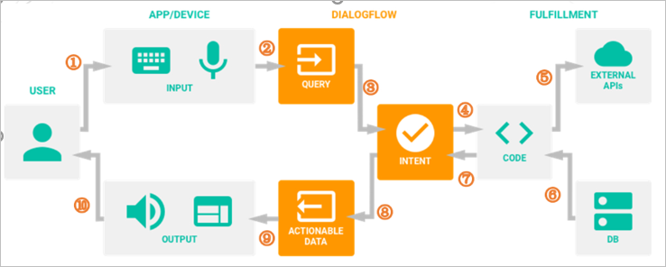

Detailed steps:

1. A user sends a text/voice message to a device or an App
2. The App/Device transfers the message to Lex
3. The message is categorized and matched to a corresponding intent (Intents are defined manually by developers in Lex)
4. We define actions for each intent in the corresponding fulfillment (Webhook).
5. When Lex finds a specific intent, the webhook will use external APIs to find a response from external databases.
6. The external databases send back the required information to the webhook.
7. Webhook sends a formatted response to the intent.
8. Intent generates actionable data according to different channels.
9. The actionable data go to output Apps/Devices.
10. The user gets a text/image/voice response.

## **What Is Amazon Lex?**

Amazon Lex is an AWS service for building conversational interfaces for applications using voice and text. With Amazon Lex, the same conversational engine that powers Amazon Alexa is now available to any developer, enabling you to build sophisticated, natural language chatbots into your new and existing applications. Amazon Lex provides the deep functionality and flexibility of natural language understanding (NLU) and automatic speech recognition (ASR) so you can build highly engaging user experiences with lifelike, conversational interactions, and create new categories of products.

Amazon Lex enables any developer to build conversational chatbots quickly. With Amazon Lex, no deep learning expertise is necessary—to create a bot, you just specify the basic conversation flow in the Amazon Lex console. Amazon Lex manages the dialogue and dynamically adjusts the responses in the conversation. Using the console, you can build, test, and publish your text or voice chatbot. You can then add the conversational interfaces to bots on mobile devices, web applications, and chat platforms (for example, Facebook Messenger).

Amazon Lex provides pre-built integration with AWS Lambda, and you can easily integrate with many other services on the AWS platform, including Amazon Cognito, AWS Mobile Hub, Amazon CloudWatch, and Amazon DynamoDB. Integration with Lambda provides bots access to pre-built serverless enterprise connectors to link to data in SaaS applications, such as Salesforce, HubSpot, or Marketo.

Some of the benefits of using Amazon Lex include:

* Simplicity – Amazon Lex guides you through using the console to create your own chatbot in minutes. You supply just a few example phrases, and Amazon Lex builds a complete natural language model through which the bot can interact using voice and text to ask questions, get answers, and complete sophisticated tasks.

* Democratized deep learning technologies – Powered by the same technology as Alexa, Amazon Lex provides ASR and NLU technologies to create a Speech Language Understanding (SLU) system. Through SLU, Amazon Lex takes natural language speech and text input, understands the intent behind the input, and fulfills the user intent by invoking the appropriate business function.

Speech recognition and natural language understanding are some of the most challenging problems to solve in computer science, requiring sophisticated deep learning algorithms to be trained on massive amounts of data and infrastructure. Amazon Lex puts deep learning technologies within reach of all developers, powered by the same technology as Alexa. Amazon Lex chatbots convert incoming speech to text and understand the user intent to generate an intelligent response, so you can focus on building your bots with differentiated value-add for your customers, to define entirely new categories of products made possible through conversational interfaces.

* Seamless deployment and scaling – With Amazon Lex, you can build, test, and deploy your chatbots directly from the Amazon Lex console. Amazon Lex enables you to easily publish your voice or text chatbots for use on mobile devices, web apps, and chat services (for example, Facebook Messenger). Amazon Lex scales automatically so you don’t need to worry about provisioning hardware and managing infrastructure to power your bot experience.

* Built-in integration with the AWS platform – Amazon Lex has native interoperability with other AWS services, such as Amazon Cognito, AWS Lambda, Amazon CloudWatch, and AWS Mobile Hub. You can take advantage of the power of the AWS platform for security, monitoring, user authentication, business logic, storage, and mobile app development.

* Cost-effectiveness – With Amazon Lex, there are no upfront costs or minimum fees. You are charged only for the text or speech requests that are made. The pay-as-you-go pricing and the low cost per request make the service a cost-effective way to build conversational interfaces. With the Amazon Lex free tier, you can easily try Amazon Lex without any initial investment.

## Amazon Lex: How It Works

Amazon Lex enables you to build applications using a speech or text interface powered by the same technology that powers Amazon Alexa. Following are the typical steps you perform when working with Amazon Lex:

1. Create a bot and configure it with one or more intents that you want to support. Configure the bot so it understands the user's goal (intent), engages in conversation with the user to elicit information, and fulfills the user's intent.
2. Test the bot. You can use the test window client provided by the Amazon Lex console.
3. Publish a version and create an alias.
4. Deploy the bot. You can deploy the bot on platforms such as mobile applications or messaging platforms such as Facebook Messenger.

Before you get started, familiarize yourself with the following Amazon Lex core concepts and terminology:

* **Bot** – A bot performs automated tasks such as ordering a pizza, booking a hotel, ordering flowers, and so on. An Amazon Lex bot is powered by Automatic Speech Recognition (ASR) and Natural Language Understanding (NLU) capabilities, the same technology that powers Amazon Alexa.

Amazon Lex bots can understand user input provided with text or speech and converse in natural language. You can create Lambda functions and add them as code hooks in your intent configuration to perform user data validation and fulfillment tasks.

* **Intent** – An intent represents an action that the user wants to perform. You create a bot to support one or more related intents. For example, you might create a bot that orders pizza and drinks. For each intent, you provide the following required information:

* + Intent name– A descriptive name for the intent. For example, OrderPizza.
  + Sample utterances – How a user might convey the intent. For example, a user might say "Can I order a pizza please" or "I want to order a pizza".
  + How to fulfill the intent – How you want to fulfill the intent after the user provides the necessary information (for example, place order with a local pizza shop). We recommend that you create a Lambda function to fulfill the intent.

You can optionally configure the intent so Amazon Lex simply returns the information back to the client application to do the necessary fulfillment.

In addition to custom intents such as ordering a pizza, Amazon Lex also provides built-in intents to quickly set up your bot. For more information, see [Built-in Intents and Slot Types](https://docs.aws.amazon.com/lex/latest/dg/howitworks-builtins.html).

* **Slot** – An intent can require zero or more slots or parameters. You add slots as part of the intent configuration. At runtime, Amazon Lex prompts the user for specific slot values. The user must provide values for all *required* slots before Amazon Lex can fulfill the intent.

For example, the OrderPizza intent requires slots such as pizza size, crust type, and number of pizzas. In the intent configuration, you add these slots. For each slot, you provide slot type and a prompt for Amazon Lex to send to the client to elicit data from the user. A user can reply with a slot value that includes additional words, such as "large pizza please" or "let's stick with small." Amazon Lex can still understand the intended slot value.

* **Slot type** – Each slot has a type. You can create your custom slot types or use built-in slot types. For example, you might create and use the following slot types for the OrderPizza intent:

* + Size – With enumeration values Small, Medium, and Large.
  + Crust – With enumeration values Thick and Thin.

Amazon Lex also provides built-in slot types. For example, AMAZON.NUMBER is a built-in slot type that you can use for the number of pizzas ordered. For more information, see [Built-in Intents and Slot Types](https://docs.aws.amazon.com/lex/latest/dg/howitworks-builtins.html).

Currently, Amazon Lex supports only US English language. That is, Amazon Lex trains your bots to understand only US English.

(Source: <https://docs.aws.amazon.com/lex/latest/dg/what-is.html>)

**Build your first chatbot**

1) Login to AWS portal [**https://signin.aws.amazon.com/**](https://signin.aws.amazon.com/)

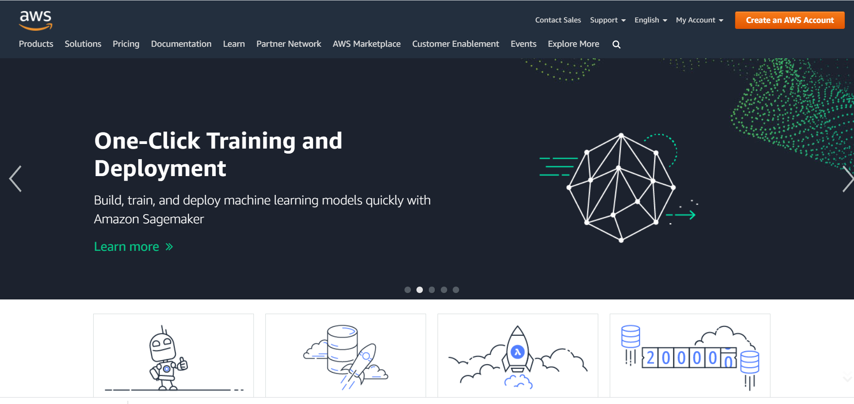

2) Click on “create an AWS Account”. Sign in with your credentials or create a new account.

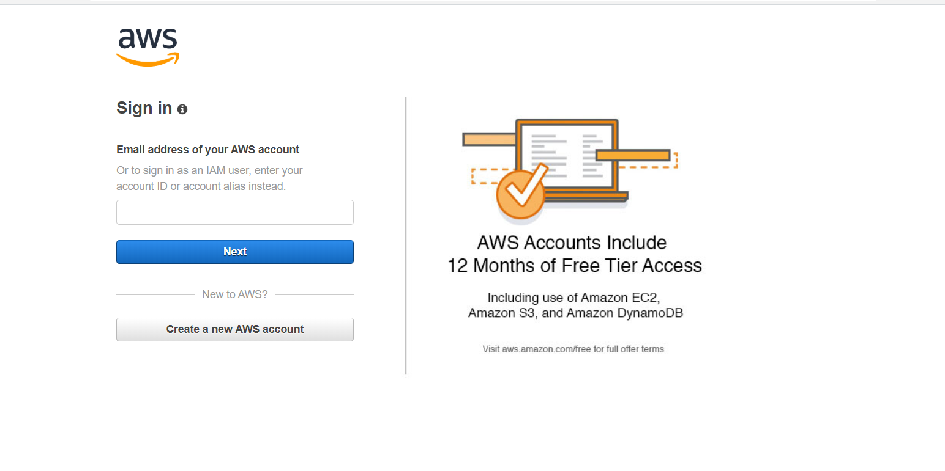

3) Once logged in, click on Amazon Lex to start creating your bot.

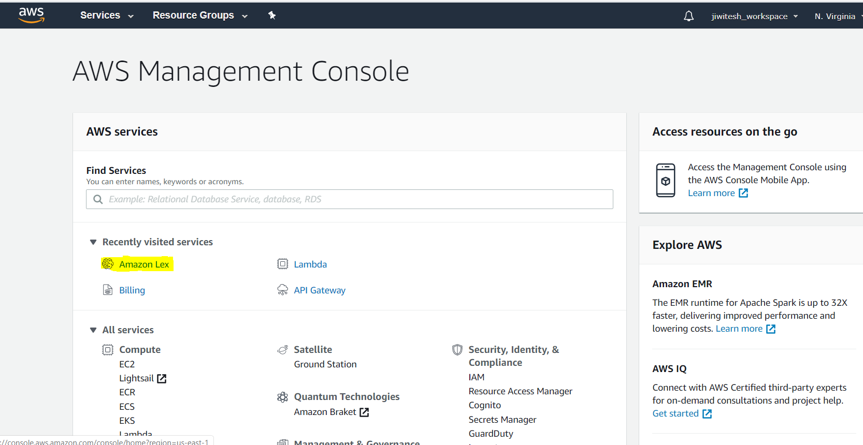

4) Click on create and create a new bot.

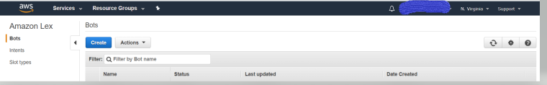

5) Once you click the create button, you will see a window like this. Click on the “custom bot” to make your own bot. The other bots are example bots and you can go through them to get a glance on some higher details.

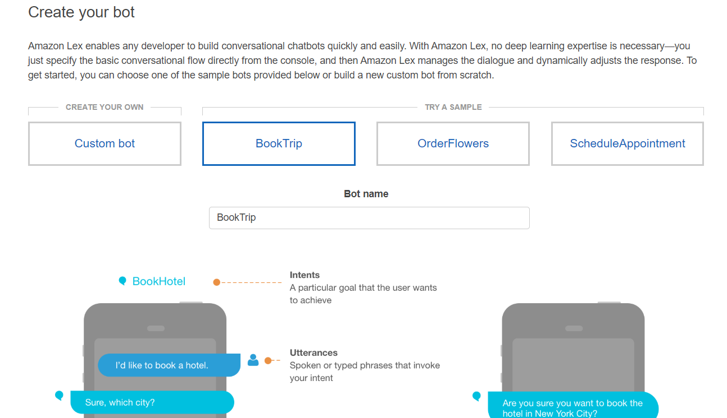

6) Fill up all the details and create on the create button.

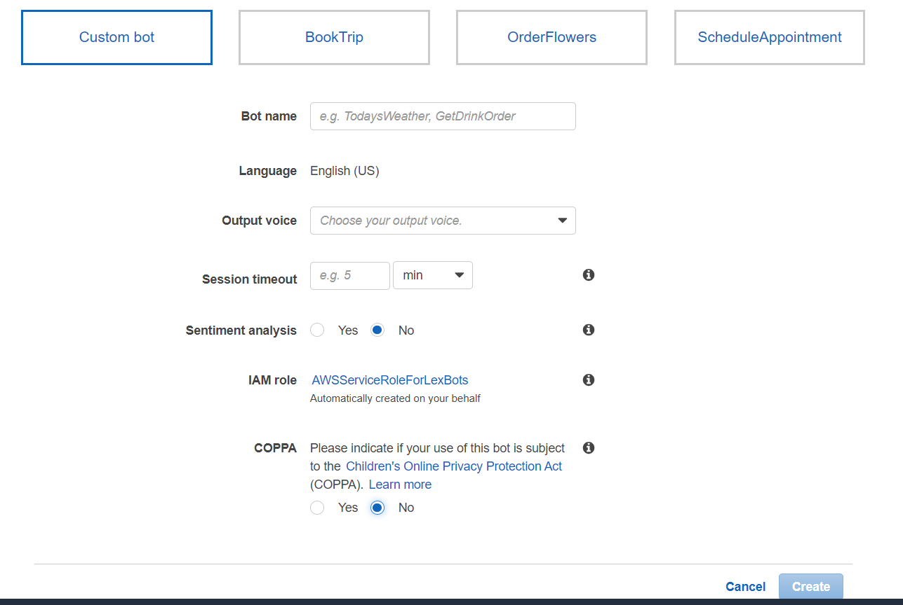

7) We have create a bot as follows:

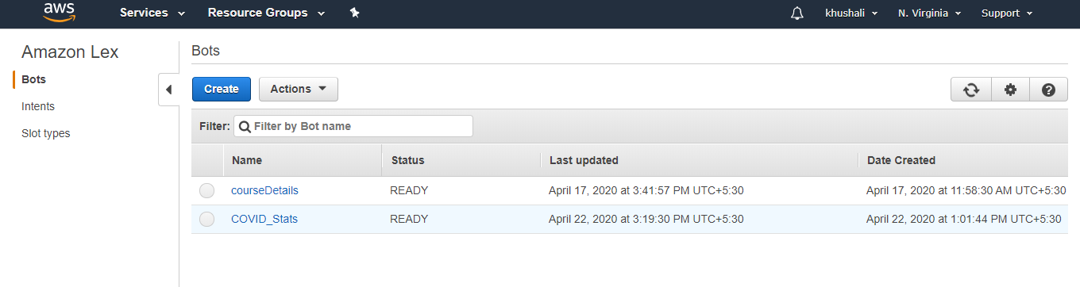

8) We will start by creating intents for our bot. Click on the plus button next to intents.

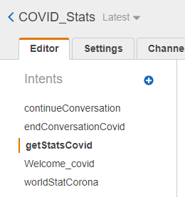

Give a name to your intent.

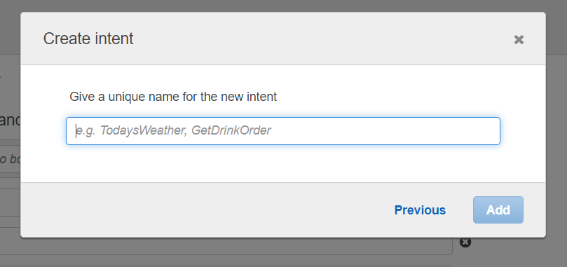

We are going to create a “Welcome” intent which will greet the user on hearing/reading the defined utterances.

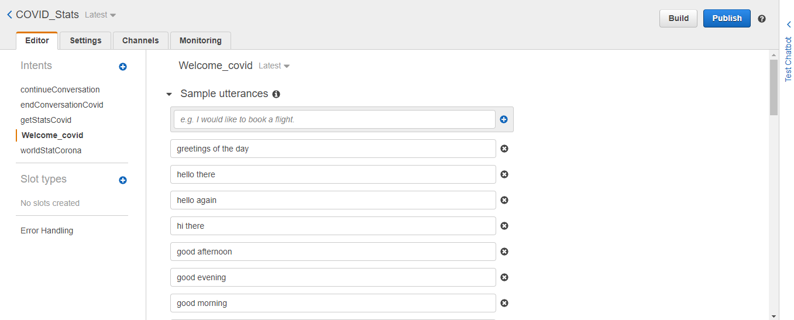

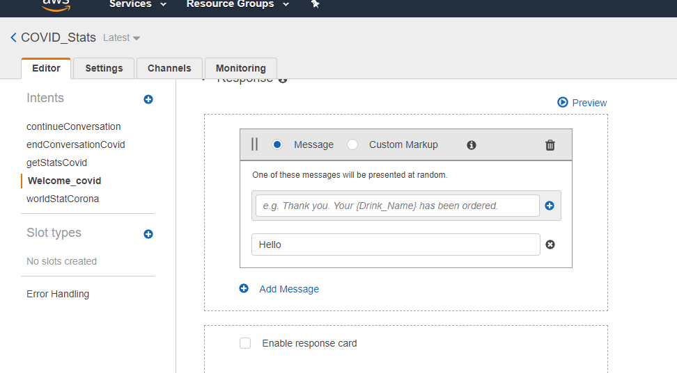

We are not filling the slots for this intent and keeping the “Fullfillment” as return parameters to client. We will see the use of slots and use of lambda function for the next intent.

In the response section, we are giving the response that the bot is going to give after hearing all the utterances we have provided.

9) Similarly we are creating new intents as per our requirements that we need the bot to respond to.

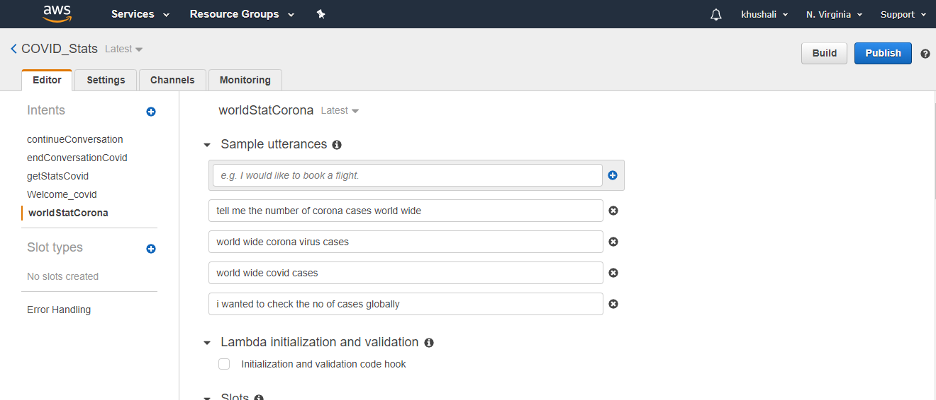

10) let’s see the Fulfillment using lambda function. We are creating one intent with sample utterances and once our bot receives that intent, it will ask the user for its details like name, mobile number and email and pin-code. Then it will send a mail to the user with the number of cases of coronavirus at user requested area and precautions through requesting a callback.

Let’s see how we are going to do it.

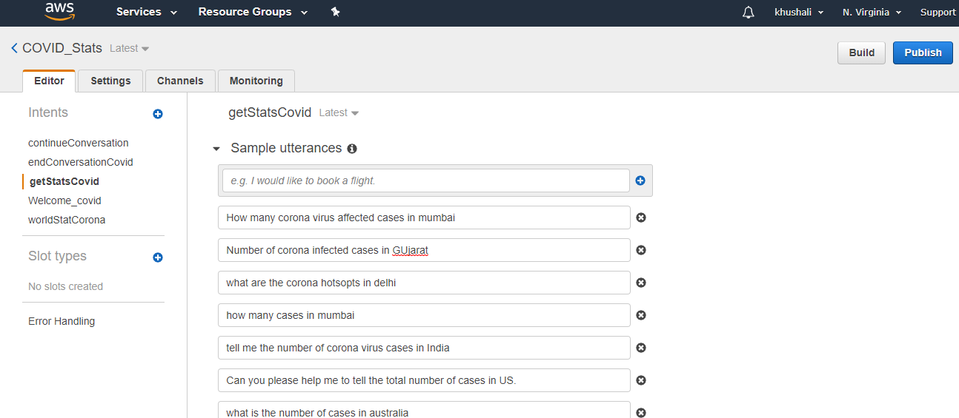

Once we have filled up the sample utterances. Let’s fill the slots that we will be prompting the user for getting the user details.

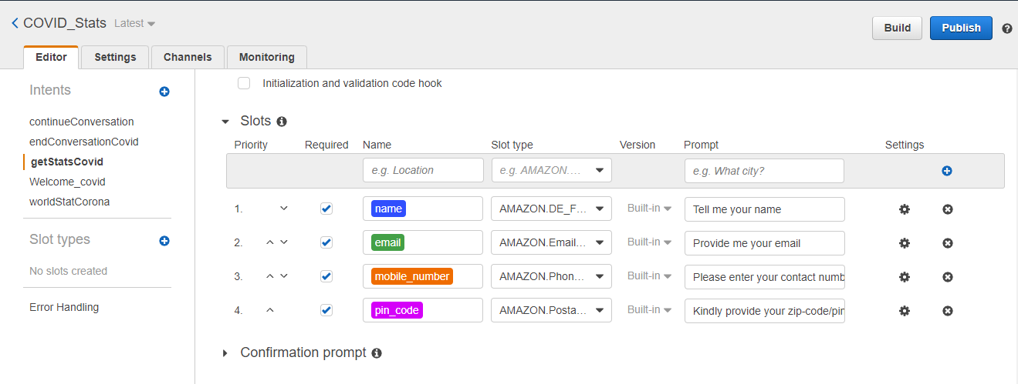

In the slot name we give the values that we want from the user. The slot\_type is the default validation parameter in Lex and we can use that to validate the values user gives against that slot. In the prompt we are going to prompt the user with the specific questions to get the slot values.

In the Fulfillment section, we are using Lambda function to send an email to the user on the given email id and to the support team with all the user details.

Let’s see how to create the lamda function.

Go to the AWS console and click on “Lambda” inside the ”compute” section.

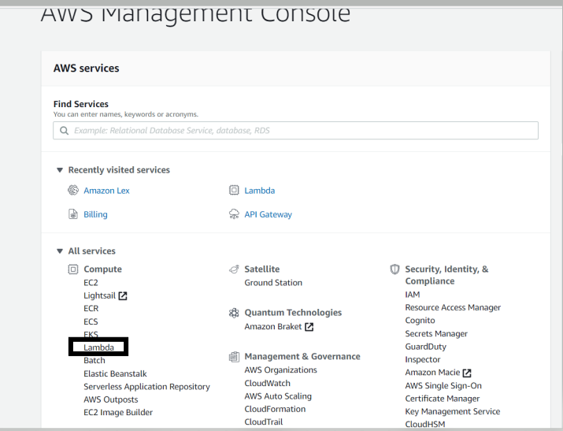

Click on the “create function” tab.

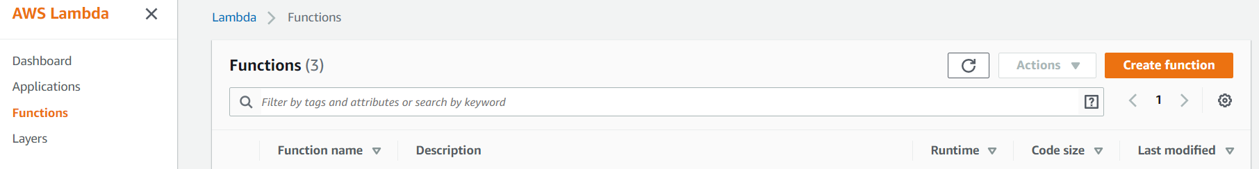

Given the name of the function and select the runtime as “python”, you can select other runtimes as well. Click on the create function.

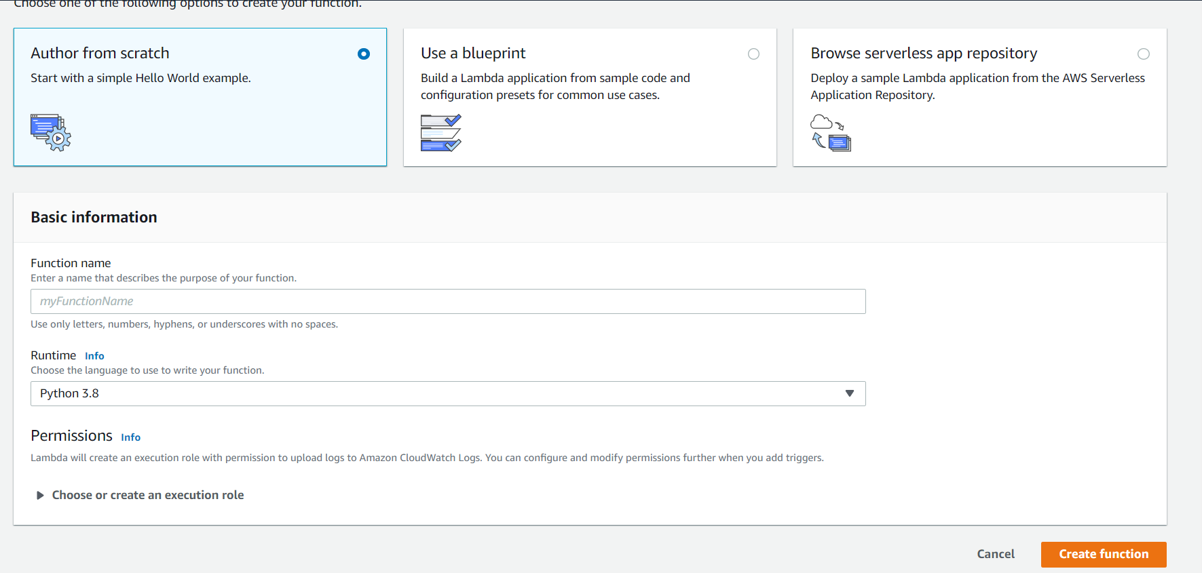

We have created a function named “sendEmail”. After clicking the “create function” button, you will see a page like this :

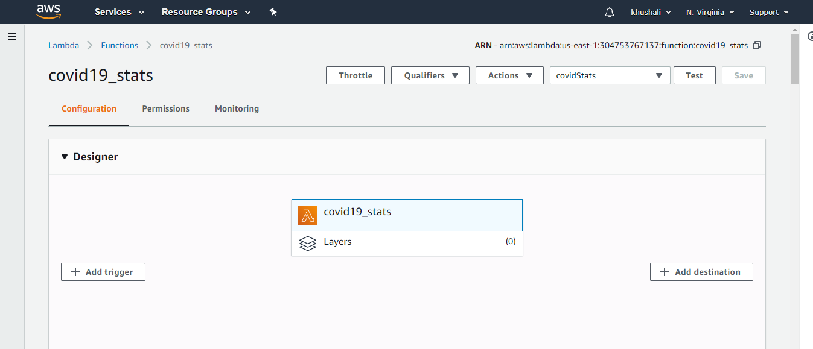

Go to the “Function code” section:

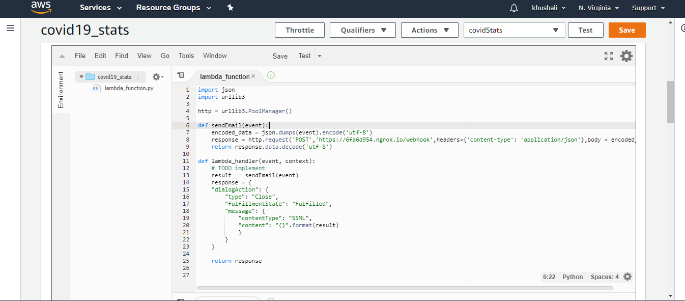

The function with name “lambda\_handler” is the function first called once an intent with fulfilment as lamda is called and the it is passed as the “event” argument in the function.

We are sending this event argument to the backend call and accordingly we will get response from our backend to lambda function and it will give output to our chat bot.

This sendemail function hits an “Api” using the post method. We pass all the event details in the api in a json format. The Api returns a message on successfully sending the argument to our backend.

We have written a python code and deployed it as an “Api” which we are directly calling throught this “sendEmail” function.

We are keeping the Lambda function as simple as possible and we will not add any more functionality. Let’s test our function written in the lambda.

For running the test, firs save our lambda function, then click on the “configure test events”

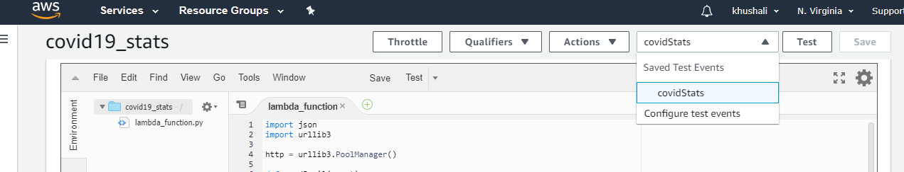

You will see fields like this, create a new test event and set default values for the slots for testing the lamda function:

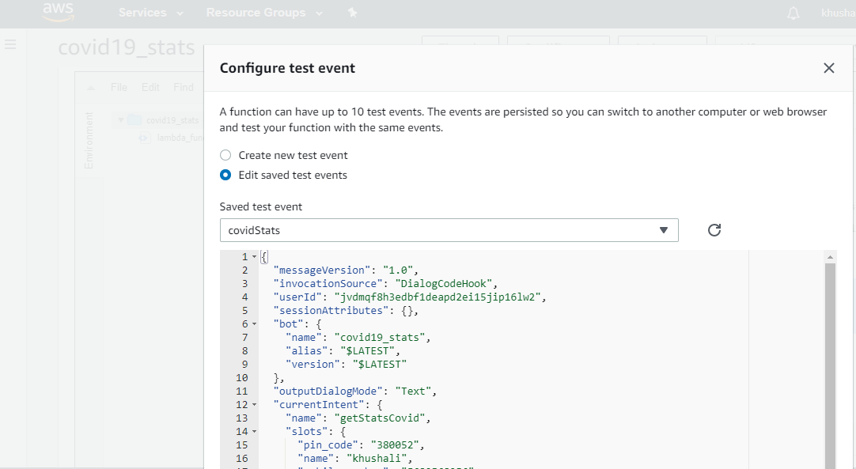

Once the default values are set. Let’s test our bot. Click on the test bot.

You will see a success message if your test works else receive an error status.

Now that we have created all of our intents. You can test your bot with the intents by “building” you bot.

Click on the “build” button to build the bot:

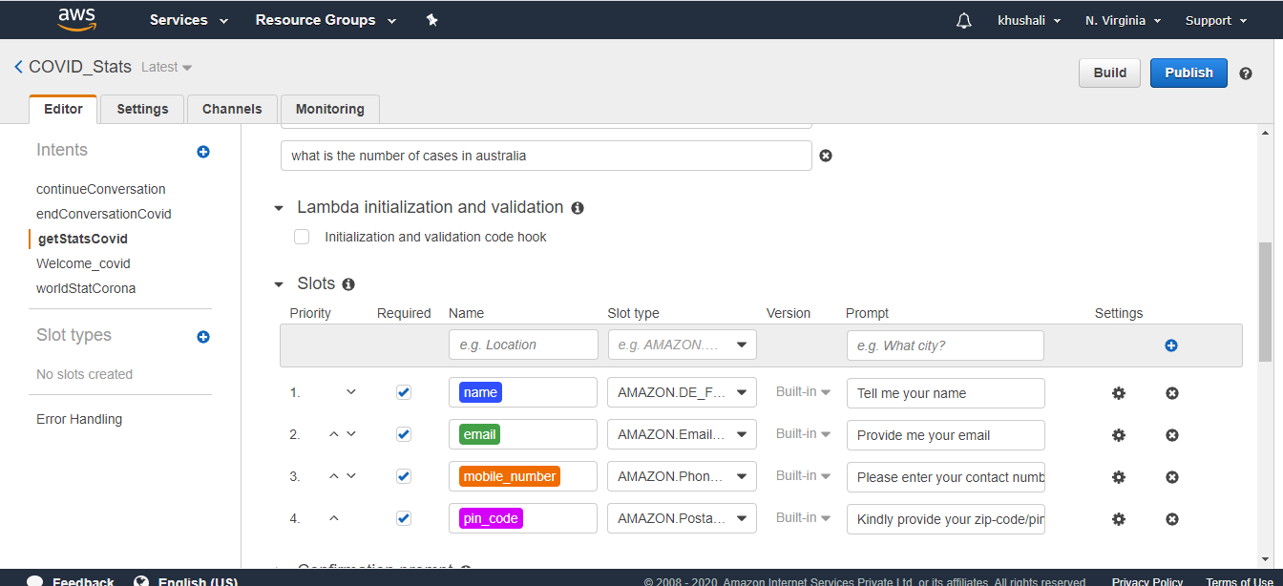

Wait till you get the message that you bot is ready for testing.

Let’s test our bot in the “Test Bot” window on the right.

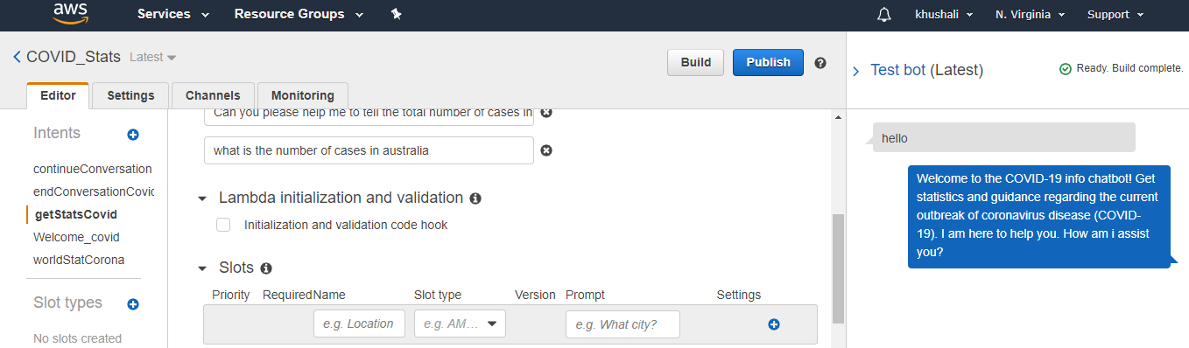

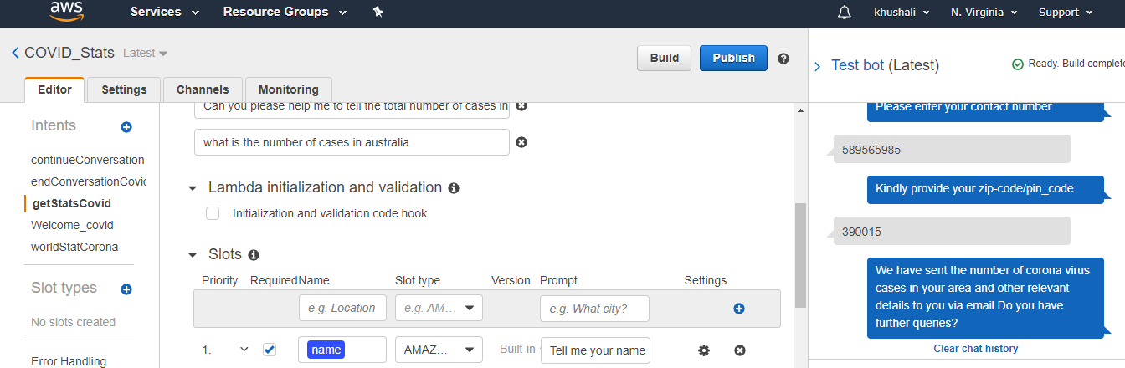

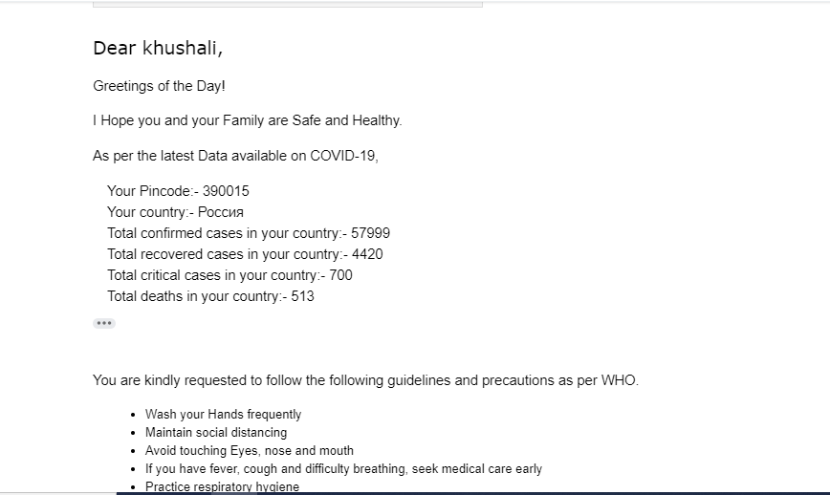

Now that we have built our bot and it’s working fine. Let’s go ahead with publishing the bot.

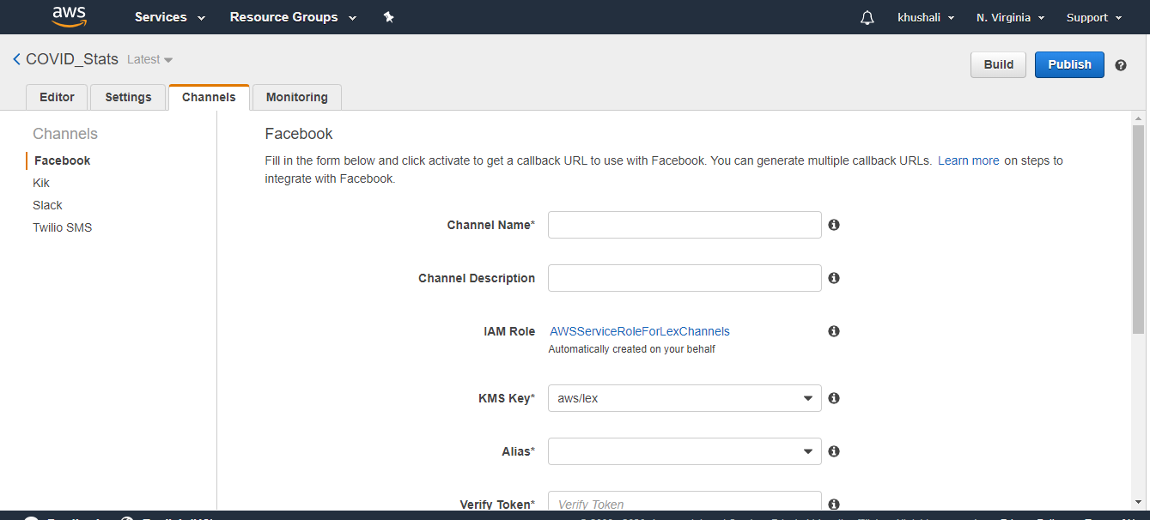

Let’s deploy our bot on Facebook. Clik on the “Go to Channels”.

**DEPLOYMENT ON FACEBOOK**

Go to Facebook and create a page on which we will be integrating our chatbot. We have “AwsTest” page created already on facebook.

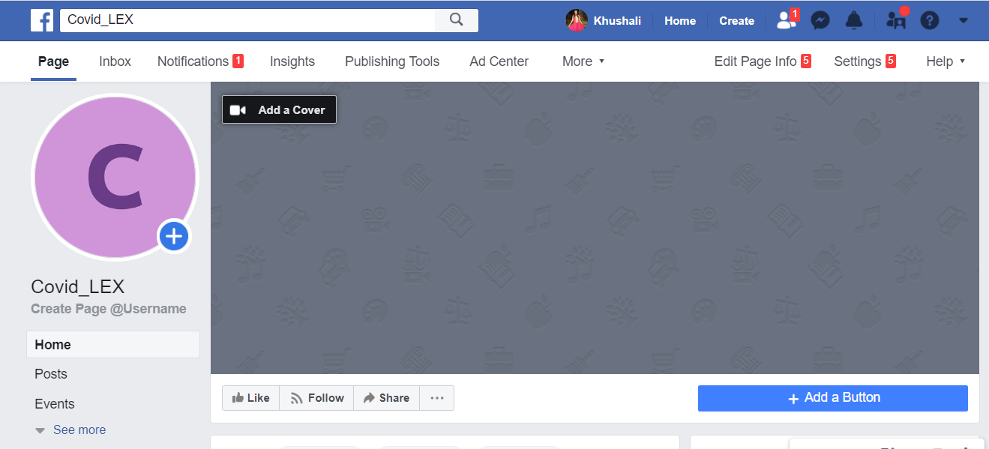

Go to Facebook for developers and click on Get started.

If you are a new user, create an account on facebook for developer and then proceed.

Click on “create first App”

Give a display name

Complete the security check:

You will see the below page once the app is created. Click on the messenger tab and then on the setup button:

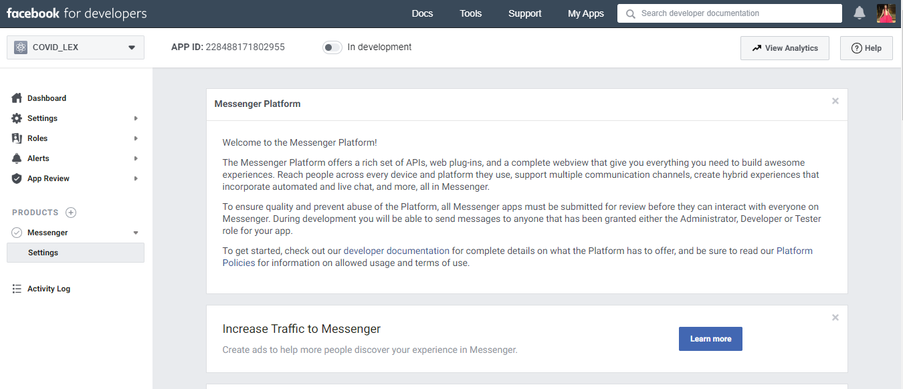

Now go back to your Lex bot page and enter the details as shown below:

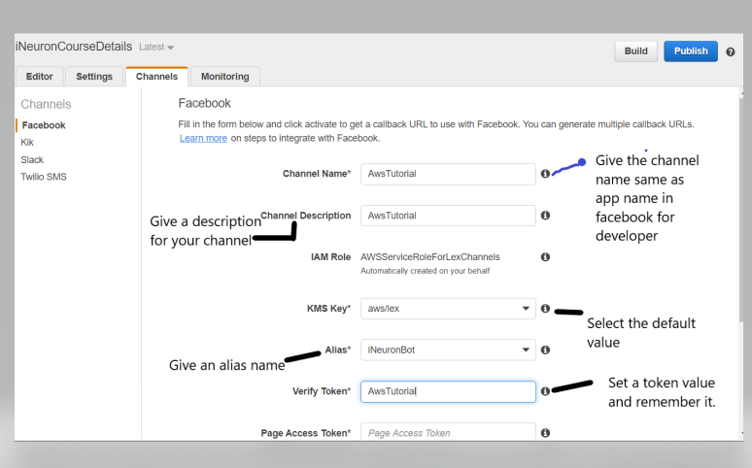

To get the page access token, go back to your app in Facebook for developers, click on settings below messenger and then scroll down to come to the access token section:

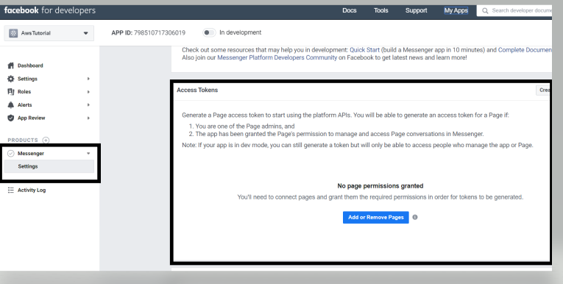

Click on the Add or remove pages button to add the page created on facebook. You will see a popup , press continue as:

Select the app from the list :

You will get a successful message:

You will see the access token section changed like this :

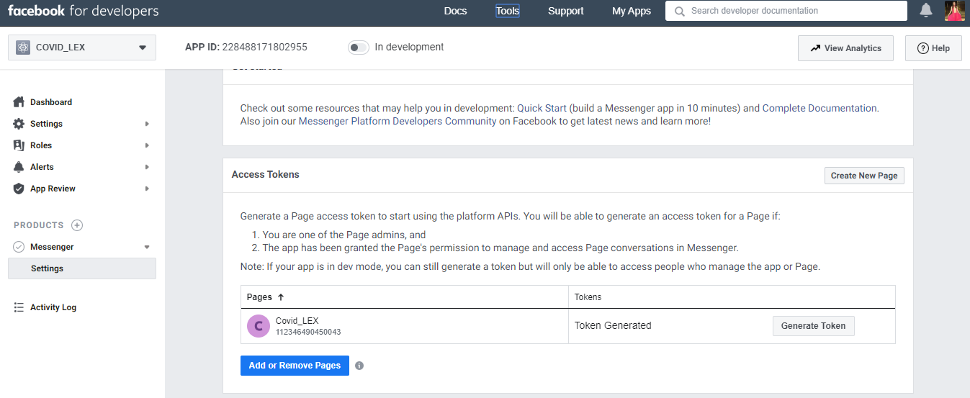

Paste the code to the page access token section of your Bot channel page:

Now for app secret key, go back to facebook for developers and click on basic tab below settings:

You will see a page like this after clicking. Click on the show button, you will prompted to enter your password for facebook, enter your password and you can copy the code:

Copy the app secret and come back to your bot channel page and paste in the app secret field:

Click the activate button after filling all the details. You will get an endpoint url as shown below after activation. Copy the url:

Go back to facebook for developer page in messenger settings tab:

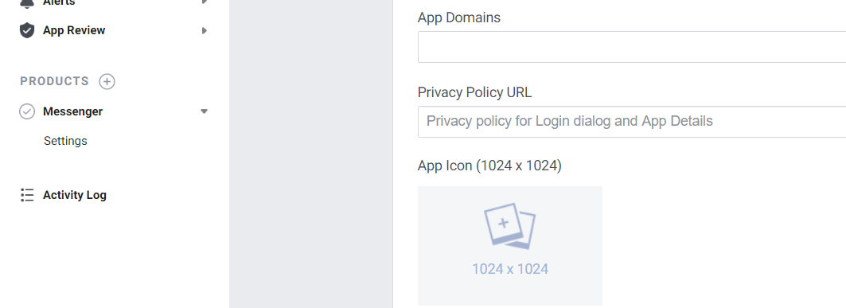

Click on add callback url under webhooks section:

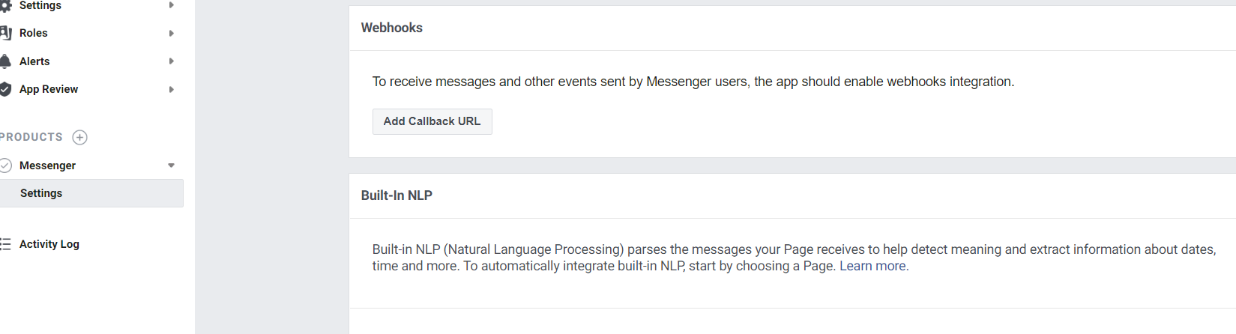

Enter all the details, paste the url in the first box and in second field enter the token value created at the bot channel page:



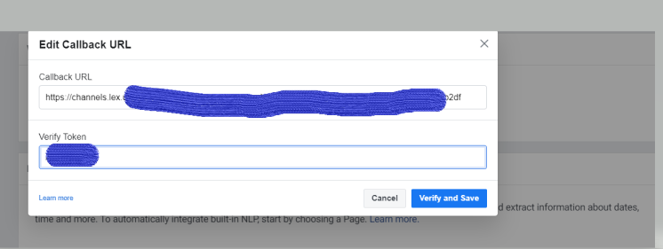

After clicking erify and save, the webhook section will be updated and you can see an Add subscription button like below. Click on it.

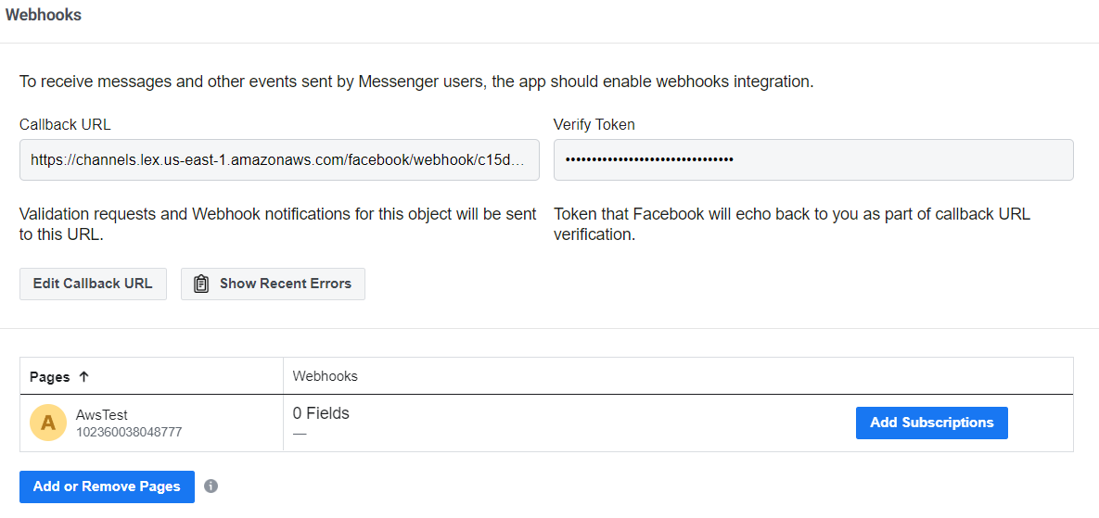

After clicking, check the messages box and save.

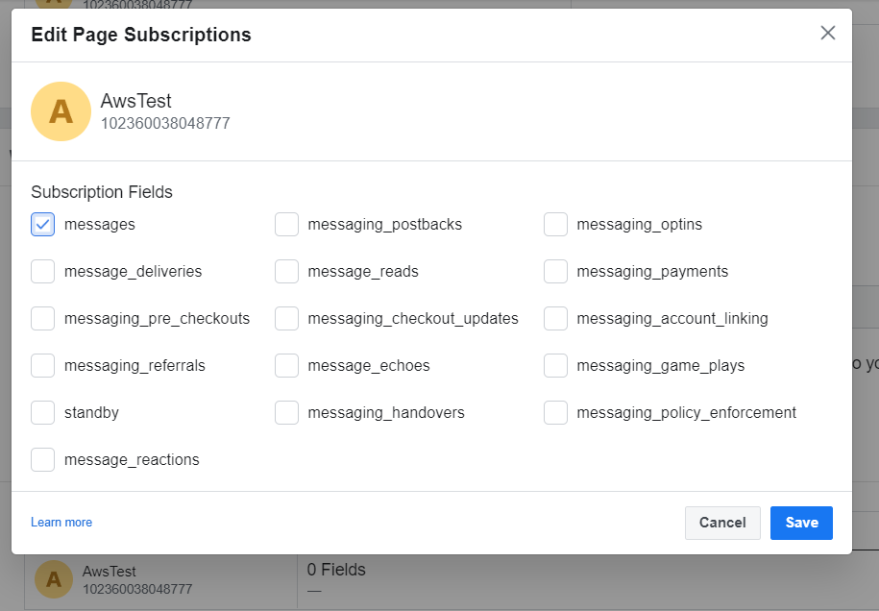

Now the setup is completed. Go to your page on facebook and hit refresh.

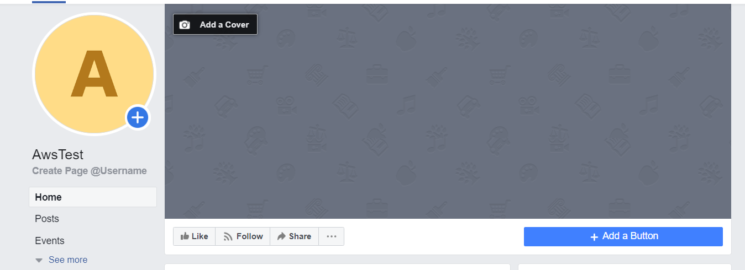

Click on Add a button.

Select the “send message” button in the “Contact you” tab and click next.

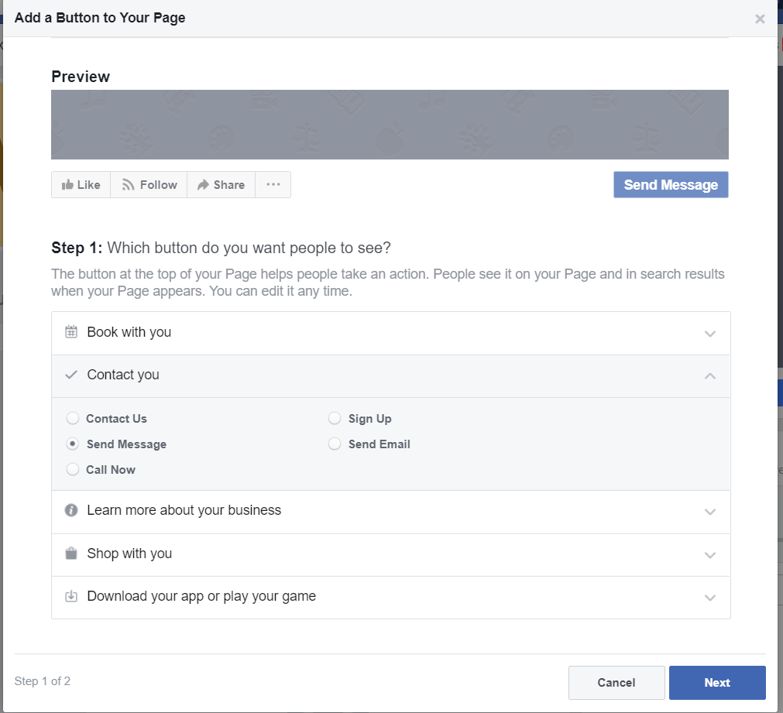

Click on messenger on the next page and click finish.

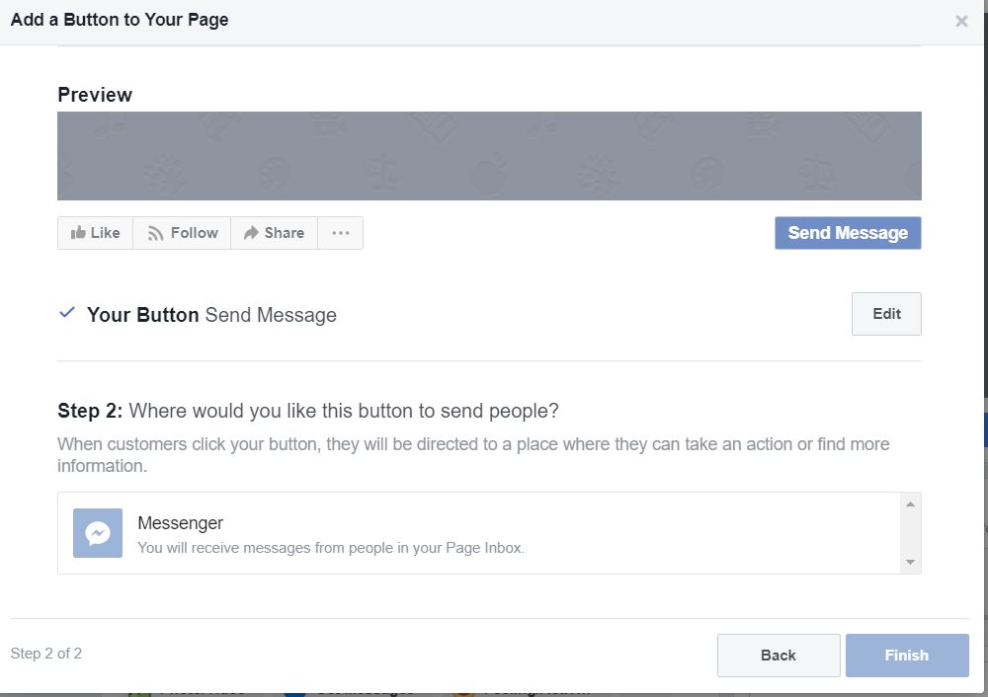

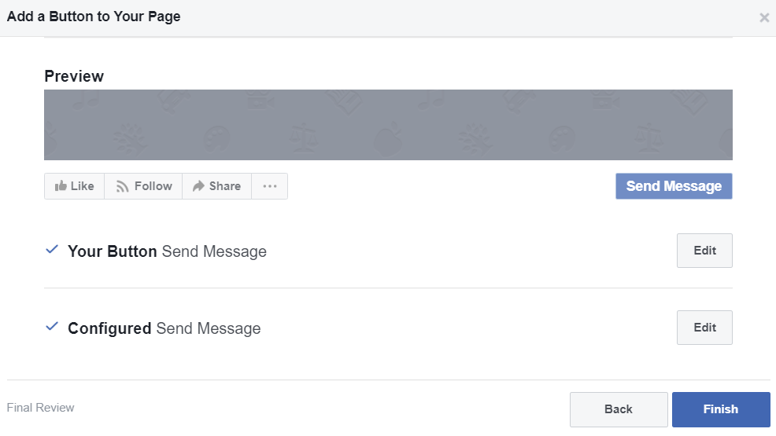

Now your chat bot is ready to be used.

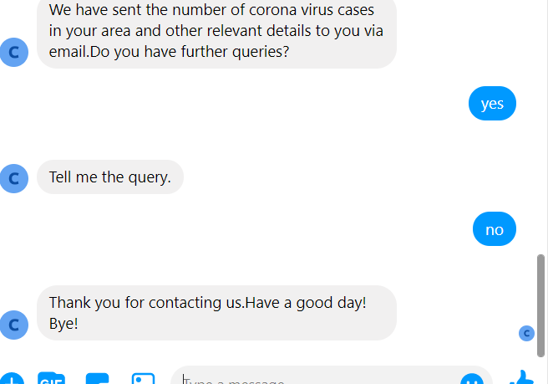

Note:- Here for google dialogFlow, code is deployed on cloud platform, while for Amazone lex, code has been running locally.

Thank you!